DEVELOPING MATHEMATICS TEACHING MATERIALS ON SPLDV MATERIALS BY COMBINING THE SCIENTIFIC APPROACH AND THE RME APPROACH TO IMPROVE METACOGNITIVE ABILITY AND LEARNING INDEPENDENCE OF JUNIOR HIGH SCHOOL STUDENTS
Sigit Mulqiyono¹, Wahyu Hidayat², Euis Eti Rohaeti³
¹Institut Keguruan dan Ilmu Pendidikan Siliwangi, JL. Terusan Jenderal Sudirman, Cimahi, Indonesia.
mulqiyonosigit0@gmail.com1
²Institut Keguruan dan Ilmu Pendidikan Siliwangi, JL. Terusan Jenderal Sudirman, Cimahi, Indonesia.
wahyu@ikipsiliwangi.ac.id2
³Institut Keguruan dan Ilmu Pendidikan Siliwangi, JL. Terusan Jenderal Sudirman, Cimahi, Indonesia.
e2rht@ikipsiliwangi.ac.id3

ARTICLE INFO |  | ABSTRACT
Article history: |  | This study aims to develop teaching material in the form of a mathematics learning module on SPLDV material and to improve students' metacognitive abilities and also students' learning independence. This research was conducted in four junior high schools as a place for the initial field test, the main field test, and the operational field test. The indicator of the success of this research is seen from the level of validation given by the validator, namely material experts and media experts of 75%. As for the success of learning, it can be seen from the significance obtained from the statistical test results from the results of the metacognitive ability test and student learning independence questionnaire. The results of this development research showed that: 1) The results of the validation test of the two experts found that the teaching materials developed were in good classification with a percentage of 89.4% for material experts and 83.3% for media experts. This means that the teaching materials meet the classification to good practice and implementation. So it is feasible to use and be tested. 2) At the product trial stage, students' responses to the teaching materials were quite good with a percentage of 81.28% for the initial field trial and 83.01% for the main field test. Student responses to learning using the teaching materials that were developed also had good criteria at the time of operational trials with a percentage of 78%, 3) from the results of statistical tests with a significance level of 0.05, metacognitive abilities, and student learning independence using the developed teaching materials had increased. significant. So that the development of teaching materials can affect the mastery of students' mathematical and affective abilities.
Received Jan 01, 2021
Revised Jan 12, 2021
Accepted Jan 15, 2021
Keywords:
Metacognition
Student learning independence

Metacognition  Student learning independence |  | Copyright © 2021 IKIP Siliwangi.  All rights reserved.
 |  | Corresponding Author:
Sigit Mulqiyono,
Department of Mathematics Education,
Institut Keguruan dan Ilmu Pendidikan Siliwangi,
Jl. Terusan Jend. Sudirman, Cimahi, Indonesia
Email: mulqiyonosigit0@gmail.com
How to Cite:
Mulqiyono. S., Hidayat, W., & Rohaeti , E. E., (2022) Developing Mathematics Teaching Materials on SPLDV Material by Combining a Scientific Approach and an RME Approach to Improve the Metacognitive Ability and Learning Independence of Junior High School Students . JIML, X(X), XX-XX.

INTRODUCTION
Mathematics is one of the compulsory subjects that need to be applied starting from primary and secondary schools because mathematics can train someone in developing their thinking skills. Muhtadi, Saputro, & Yuliani, (2019); and Rachmady, Anggo, & Busnawari (2019) explain that the application of mathematics learning is important to be given both at the elementary and middle school levels because it can train students' thinking skills and shape their personalities. Where students are trained how to think logically, systematically, creatively, critically, and analytically in solving a problem.
Problem-solving itself is one of the mathematical abilities that must be possessed by students after studying mathematics. Where problem-solving is included in one of the objectives of learning mathematics in schools, as stated in Ministerial regulation no. 23 of 2006. In addition, Nirfayanti & Erna (2021); and Fitria, (2018)explain that one of the general goals of learning mathematics is to be able to solve problems. Whether it's a problem in learning or students' daily lives. The importance of mastering problem solving was also conveyed by Puadi & Habibie (2018); Anisah & Lastuti, (2018); and Ariawan & Nufus, (2017) that problem solving is an important mathematical ability to be mastered by students after studying mathematics.
However, the results of research conducted by Suraji, Maemunah & Saragih (2018) show that students' ability to solve a problem is still relatively low, especially in questions related to everyday life. Likewise, according to Nirfayanti & Erna (2021) which explains the ability of students to solve non-routine problems that require mathematical reasoning is still relatively low. Therefore we need an ability that can support the improvement of the problem-solving process, one of which is the ability of metacognition. Where this ability has a fairly good influence on the problem-solving process. The results of research that show this are one of the results of research conducted by Thayeb & Putri, (2017) which explains that metacognitive abilities affect the improvement of students' problem-solving abilities. This is also reinforced by the statement of Coşkun, (2018); Novita, Widada, & haji (2018); Fauziana, Budiarto, & Wiryanto (2020) and Syafrudin, (2021) that metacognition can help students solve a problem, because the higher the metacognition ability, the higher the success rate in solving a problem.
Metacognition ability can be interpreted as a person's ability to control and manage his thoughts. Or simply we can interpret thinking about thinking. Nirfayantis & Erna (2021); and Thayeb & Putri, (2017), argue that metacognition is a student's process of realizing abilities and thinking in solving a problem. Where metacognition is a process that includes perception, understanding, remembering, etc. (Coşkun, 2018). Meanwhile, according to Amir & Wardana, (2018) and Syafrudin, (2021) argue that metacognitive ability refers to higher-order thinking skills that involve active control of cognitive processes to arrange appropriate learning strategies to achieve learning goals. Of course, this makes metacognition important to master to support the success of problem-solving because it includes students' cognitive processes.
From the explanation above, metacognitive ability requires independence from students to develop properly. Because students are required to be able to design, manage and evaluate appropriate learning strategies for themselves by realizing their strengths and weaknesses and how to overcome them. In addition, independence is also closely related to success in problem-solving. The results of research by Mayasari & Rosyana, (2019) and Ambiyar, Aziz, & Delyana, (2020) show that there is a positive relationship between learning independence and students' ability to solve a problem. Therefore, learning independence and metacognitive abilities are important to develop because they have a positive relationship to problem-solving.
One way that can be used to improve metacognition and learning independence is the need for teaching material. Where the teaching material itself is one of the basic components in the learning process in the form of a set of materials or other learning support tools that are arranged systematically so that they can help teachers in learning activities in the classroom. As stated by Nurhidayati, Tayeb dan Abbas (2017) teaching material is a learning device containing material that can help teachers or students in learning activities in class that is designed systematically. This certainly shows that teaching materials are one of the factors supporting the success of the student learning process and is one component that is as important as the approach and learning strategies that will be applied in the teaching and learning process in the classroom.
So far, in learning, students have been provided with textbooks for learning mathematics, but these textbooks have not been able to facilitate students in increasing the competence of students' abilities. Although in the textbook the material presented is very complete, for students themselves it is still quite difficult to understand the material presented. It can be seen from the observations that the researchers did when teaching students more listening to what the teacher said while teaching without being directly involved in learning. Whereas according to Gazali, (2016) ideally, the textbook should contain learning materials and processes, assessment systems, and expected competencies. . Thus, the expected learning objectives will be easily achieved.
Referring to the previous explanation, this research focuses on the development of mathematics teaching materials by combining two approaches, namely the scientific approach and the RME approach, which are oriented towards increasing the metacognitive ability and learning independence of junior high school students. And the product developed is in the form of mathematics teaching materials that have been adapted to the characteristics of students. And the material taken in this research is the material for the two-variable linear equation system (SPLDV). Where according to Putri, (2016); Gazali, (2016); Lestari, (2018); and Nurhidayati, Tayeb & Abbas (2017) state that the development of teaching materials is an activity in preparing the implementation of learning by providing appropriate teaching materials by considering the needs of students, as well as increasing the effectiveness of learning and improving the quality of learning. especially in the 2013 Curriculum.
To meet the needs of students for the availability of appropriate teaching materials, two approaches were chosen, namely the scientific approach and the RME approach as an alternative approach. Wherefrom the research results of Nurhikmayati & Jatisunda, (2019) that scientific-based teaching materials are more effective when compared to teaching materials in the form of textbooks. Likewise, with the RME approach, Haryonik & Bhakti, (2018) explained that the development of teaching materials that apply a realistic approach is by the qualifications of the LKS and is feasible to use. Therefore, researchers are interested in taking the title of development research as follows "Developing mathematics teaching materials on SPLDV material by combining a scientific approach and an RME approach to improve the metacognitive ability and learning independence of junior high school students".
METHOD
This research is development research that aims to develop a learning device or mathematics teaching material on the material of the Two-Variable Linear Equation System (SPLDV). This research method is also known as the Research and Development (RnD) method. Where according to Saputro (2017); and Muqdamien, Umayah, Juhri, & Raraswaty (2021) this research method is a form of developing innovation from a product, either new or existing so that it looks more attractive and by learning objectives and certain subjects.
And there are also phases of research that are taken in this research are 10 phases of development according to the model of Borg & Gall, (1983) :
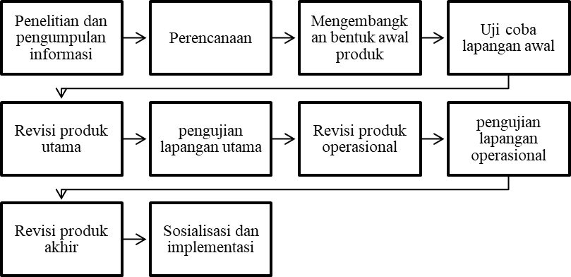
Figure 1. Research Phase of Borg & Gall Model Development
And the subjects in this study were 11 class VIII students from At-Tamimi Middle School in the initial field test, 40 class VIII students from SMPN 1 Ngamprah, and SMPN 1 Margaasih, each of which were 24 students and 16 students for the main field test. , as well as 67 students of SMP Telkom Bandung as the subject of operational field testing which is divided into two classes, namely class VIII A with 33 students and class VIII B with 34 students.
For operational field testing, research subjects were given different treatments between classes. Where for class VIII A as an experimental class, learning is given using the materials that are being developed, namely the mathematics learning module on the SPLDV material by combining the scientific approach and the RME approach, while for class VIII B the learning that takes place uses teaching materials commonly used, namely mathematics learning textbooks.
The research instruments used in this study were 5 items of mathematical metacognition ability test, an attitude scale questionnaire to measure student learning independence, and teaching material validation instruments to measure the quality of teaching materials being developed. The success indicator of this research is in the form of a product developed, namely mathematics teaching materials in the form of modules on the SPLDV material with a feasibility level according to mathematicians and media experts by 75% and an increase in students' metacognitive abilities and independence.
RESULTS AND DISCUSSION
Results
Development of Teaching Materials
The development of these teaching materials has the aim of producing teaching material in the form of a mathematics learning module on the material of a two-variable equation system (SPLDV). The development of teaching materials took 10 research phases of the Borg & Gall model. In the early stages of research, it begins with collecting information related to teaching materials that will be developed either by conducting a needs analysis that aims to identify problems in learning activities or conducting library research to find empirical data that will be needed in development activities. After the data has been collected, a product development plan (teaching material) is started, starting from the development objectives, targets, or objectives of the product being developed, as well as what research procedures will be followed in the development process.
After the initial stage is completed, namely planning and data collection, the next stage is the product development stage and the product trial stage which consists of two product development tests. Namely validation trials and field trials. The self-validation trial involved material expert validation tests and media expert trials, while the field trials consisted of initial field trials, main field trials, and operational field trials.
At the product development stage, an initial design is formed from the teaching materials that are being developed which will then be validated by media experts and material experts. Where one of the objectives of this validation test is to test the feasibility of the teaching materials being developed whether it is feasible to be tested or not. And from the results of the validation test obtained with the following results.
Table 1, Product Validation Test Results
Test | Percentage | Classification
Material Expert | 89.4% | Good
Media Expert | 83.3% | Good

From the table above, we can see if the validation results from material experts are in good classification with a percentage of 89.4% with the aspects being assessed, namely, aspects of content feasibility, aspects of presentation feasibility, and aspects of grammatical feasibility. Meanwhile, for media experts, the aspects assessed were implementation aspects, graphic feasibility aspects, and grammatical aspects with validation results from media experts amounting to 83.3% with good classification. This shows that the teaching materials developed are suitable for field trials. By going through the revision stage first based on suggestions and comments from experts.
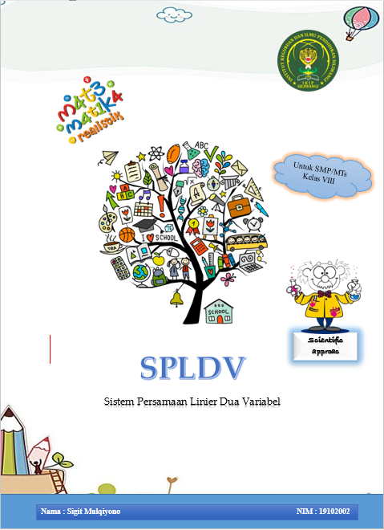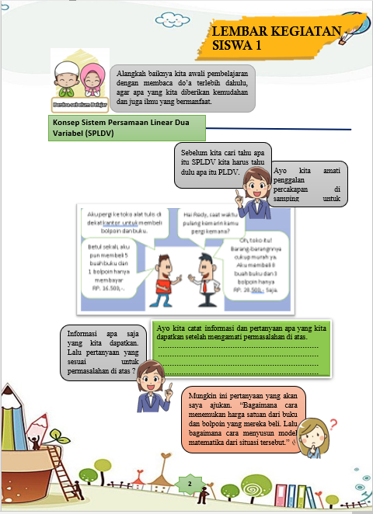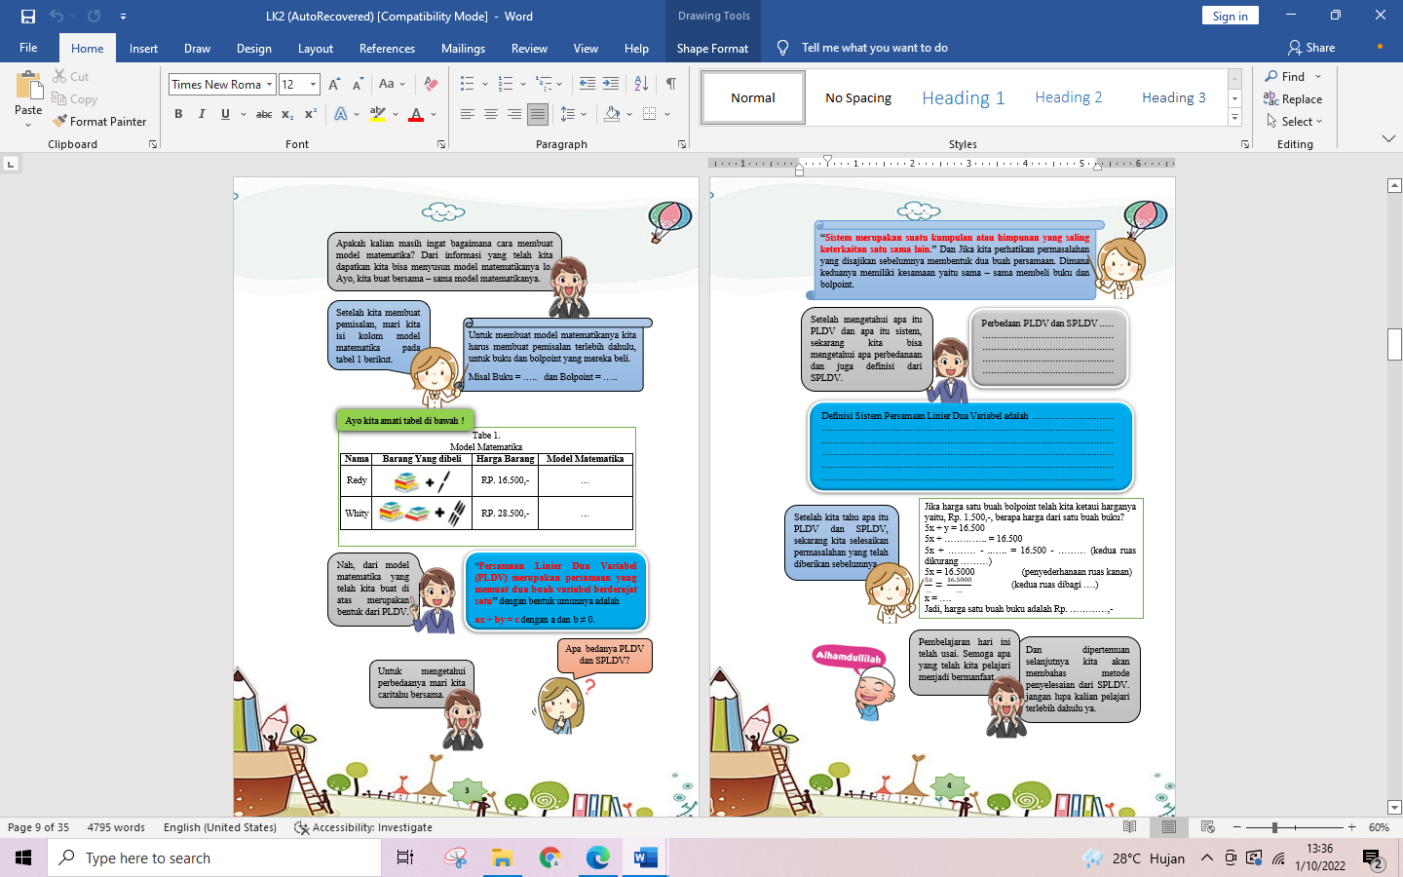
Figure 2. Math Learning Module
After entering the validation stage, the product teaching materials developed entered the trial stage which was divided into three trial stages, namely initial field trials, main field trials, and operational field trials. At each stage of the field trial, the teaching materials developed always go through revisions before going to the next step.
Table 2, Test Results of Teaching Materials
Test | Percentage | Classification
Early Field | 81.3% | Good
Main Field | 83.01% | Good
Operational Field | 78% | Good

And from the three stages of field trials that were carried out, it was found that the percentage of attractiveness and practicality of the developed teaching materials had fairly good criteria, which can be seen in table 2. So that the developed teaching materials deserve to be disseminated more widely. As an alternative solution for learning mathematics in class.
Mathematical Metacognition Ability and Student Learning Independence
In this study, besides aiming to develop a mathematics teaching material on SPLDV material by combining a scientific approach and an RME approach, this study also aims to determine the increase in mathematical metacognition abilities and also student learning independence after learning using the developed teaching materials. By giving tests to students using 5 items of mathematical metacognition ability and student learning independence questionnaires. Where the measurement of metacognitive ability and learning independence is carried out during operational field testing of the teaching materials developed.
Table 3. Statistical Data of Mathematical Metacognition Ability Test
Variables | Statistical | Experimental class |  |  | Control class
Variables | Statistical | Pretest | Posttest | N-gain | Pretest | Posttest | N-gain
Metacognitive Ability  Mathematical | N | 32 |  |  | 34
Metacognitive Ability  Mathematical | Mean | 7,06 | 22,82 | 0,30 | 6,65 | 17,76 | 0,21
Metacognitive Ability  Mathematical | St. Dev | 2,331 | 7,502 | 0,12 | 2,411 | 5,123 | 0,09
Metacognitive Ability  Mathematical | % | 11% | 36% |  | 11% | 30%

Pretest Postes N-gain Pretes Postes N-gain from the results of testing the statistical data in the table above, we can see that the metacognitive ability of students whose learning uses teaching materials by combining the scientific approach and the RME approach that is developed is better and has a more significant increase compared to classes that only use ordinary teaching materials in the form of textbooks. mathematics. This can be seen from the results of the pretest, posttest, and N-Gain analysis for both classes.
At the time of processing the pretest data, it was found that there was no difference in the initial metacognitive abilities of the students of the two classes with the average test obtained of 7.06 and 6.25. The pretest was given before the different treatment was given to the two classes. In contrast to the results of testing the pretest data and N-Gain. After carrying out learning with different treatments in the two classes, the results of the pretest test for both classes increased with a more significant increase in the class that received different treatment, namely the experimental class with an average posttest value of 22.82 and an N-Gain of 0, 30. While the class average value of the control posttest is 17.76 and the N-Gain is 0.21. This of course shows that the application of the combined scientific approach and RME approach in learning shows positive results in increasing mathematical metacognition abilities and student learning independence.
Likewise with the results of the data analysis of student learning independence tests, which can be seen in Table 4 below.

Table. 4 Student Learning Independence
Class | N | Student Learning Independence Statistics Data
Experimental class | 28 | Mean | 95,09
Experimental class | 28 | St. Dev | 11,49
Control class | 28 | Mean | 88,62
Control class | 28 | St. Dev | 6,79

That the independence of the experimental class students became better after learning by using the combination of the scientific approach and the RME approach in the classroom. Denham's average value of 95.09 compared to the control class of 88.62.
Discussion
Development of Teaching Materials
The process of developing teaching materials is guided by 10 development phases according to (Borg & Gall, 1983), namely: 1) research and information gathering, 2) planning, 3) developing the initial form of the product, 4) initial field trials, 5) major product revisions. , 6) main field testing, 7) operational product revision, 8) operational field testing, 9) final product revision, and 10) socialization and implementation. Where in the development of this teaching material begins with the collection of information through needs analysis, to find out the potential and problems before the development. This is in line with what was conveyed by Haryonik & Bhakti, (2018); and Kamal, (2020) that the development of teaching materials relies on needs analysis to find potential problems. In this way, we can determine what competencies we want to achieve in developing this teaching material so that we can answer the needs and problems that exist in learning.
After the potentials and problems are found and determine what competencies will be achieved in the development process, then a development plan and initial form of the development product are drawn up. Where in this phase everything related to the development process is prepared. Starting from time, development goals, product design, and so on including preparation of teaching materials validation tests. This validation test aims to measure the validity of the developed product whether it is feasible or not to be tested in the field. As stated by Kharisma & Asman, (2018); Muthohir, (2019); and Kamal, (2020) the activity of validating teaching materials is an activity to measure the level of validity of the teaching materials developed and the effectiveness of teaching materials whether or not it is feasible to be tested.
For the validation test of teaching materials, 6 validators are involved, namely 3 material experts and 3 media experts. The validity of the teaching materials developed was 89.4% for material experts and 83.3% for media experts. The percentage of validity given by the examiner shows that the developed teaching materials have a fairly good level of validity. So it is feasible to try out the spaciousness by first making improvements to the teaching materials based on the suggestions given by the validator.
After going through the stages of the validation test, the language was developed and then tested for spaciousness. The field testing stage is divided into three stages, namely the initial field test, the main field test, and the operational field test. At the initial field test stage and the main field test was carried out to determine the readability of teaching materials, the design of teaching materials, and also the effectiveness of the teaching materials developed. In line with what was conveyed by Kamal, (2019) who explained that the initial field test aimed to measure the effectiveness of teaching materials developed based on facts in the field. For initial and primary field testing, this can be done more than once if it is felt that there are still deficiencies in the developed teaching materials which will then be corrected based on these findings. With a percentage value of 81.3% and 83.01% for the initial and main field tests. It shows that the teaching materials have a good level of legibility and effectiveness.
In contrast to the initial field test and the main field test in operational field testing, the teaching materials developed were started to be tested in classroom learning activities by involving the experimental class and the control class and involving the pretest and posttest as an illustration of the comparison of effectiveness and the efficiency of the teaching materials developed. As stated by Kamal, (2020), this operational test involves teaching materials developed in learning activities. To measure the readiness of the teaching materials, whether they are ready to be used in learning activities or not.
After completing the operational trial process, the teaching materials developed were repaired again if it was felt that there were still some weaknesses in the teaching materials. After the teaching materials are improved, the final product is obtained in the form of mathematics teaching materials on the SPLDV material which is ready to be disseminated more widely. And in this floating research, researchers conducted socialization to teachers in junior high schools where researchers conducted operational trials in MGMP activities and also compiled a journal article so that it could be socialized more widely.
Mathematical Metacognition Ability and Student Learning Independence
To measure how the improvement of students' metacognitive abilities in the experimental and control classes, before being given different treatment in the two classes. First, an initial test (Pretest) was given to know the students' initial metacognitive abilities before being given different treatment between the two classes. And from the results of the previous pretest data analysis, it was found that there was no difference in the students' initial metacognitive ability between the two classes. In contrast to the time after the different treatment was given, where the average posttest value for the experimental class was higher than the control class as well as the results of the N-Gain test.
This shows that the combination of the scientific approach and the RME approach in learning shows positive results in improving mathematical metacognition abilities. This is supported by the statements of Aqila (2021) and Wibowo (2017), both of whom state that the application of a realistic approach and a scientific approach to learning is more effective in improving student achievement. In addition, the results of the study by Rizkiani dan Septian (2019); Sipahutar, Sinaga, dan Mulyono (2017); Zakiah, (2017); and Anggo, (2011) pointed out that the application of the Realistic Mathematics Education (RME) approach has a positive impact on increasing students' metacognitive abilities where learning involves contextual problems. Likewise with the application of a scientific approach. Jusmawati & Darwis, (2015); and Wibowo, (2017), explained that the scientific approach in learning has a positive influence on increasing learning achievement and students' mathematical abilities while studying.
For independent learning, students also show the same thing. If we look back at the data analysis table for the previous learning independence. Classes whose learning uses a combination of the scientific approach and the RME approach are superior to classes that only use the scientific approach. Indriyani, Sudarman, & Vahlia, (2020), and Arisinta, As’ari, & Sa’dijah, (2019) in their research show that increasing student learning independence by using the RME approach has a more positive impact than ordinary learning. Similarly, the results of research by Veralita, Rohaeti, & Purwasih, (2018). The application of the scientific approach in learning also shows the same thing as the results of the research of Kadarisma, (2016); and Rismalasari & Afrilianto, (2021) that the application of a scientific approach in learning can improve student learning independence for the better.
This shows that the combination of the scientific approach with the RME approach is very suitable to be applied in learning activities and the development of mathematics teaching materials. Of course, this is supported by the statement of Nurhikmayati & Jatisunda, (2019) which explains that the effectiveness of scientific-based teaching materials is better than teaching materials in the form of textbooks. And also Haryonik & Bhakti, (2018) that the development of teaching materials by applying a realistic approach is feasible to use because it is by the qualifications of the student worksheets.
CONCLUSION
From the results of the analysis of the previous results, it can be concluded that:
- The application of a combination of two approaches, namely the scientific and RME in learning can be an alternative to develop students' metacognitive abilities and student independence
- The potential and interest of students in learning mathematics.
- The application of a combination of two approaches, namely the scientific and RME can improve students' mathematical metacognition abilities and student learning independence.
ACKNOWLEDGMENTS
First of all, I would like to thank my supervisor, media expert validator and material expert, a junior high school principal who has allowed me to conduct observations and research, and all parties who have helped me in completing this research.
REFERENCES

