Jurnal Pembelajaran Matematika Inovatif
Jl. Terusan Jenderal Sudirman, Cimahi, Indonesia ISSN xxxx-xxxx (print)
Phone. +62 22 6658680, Fax. +62 22 6629913 ISSN xxxx-xxxx (online)

COPYRIGHT TRANSFER AGREEMENT FORM

Name of Principal Author: Safira Dinda Fitria
Address of Principal Author: FKIP UHAMKA, Jl. Tanah Merdeka No. 20, RT.11/RW.2, Rambutan, Kec. Ciracas, Kota Jakarta Timur 13830.

Phone: 085156502705 Fax:

E
-
mail:
safiradindafitria@gmail.com
sasa

A
u
t
hor(
s
)

N
ame
:

Safira Dinda Fitria dan Samsul Maarif

Manuscript No.

Judul Artikel : HAMBATAN EPISTEMOLOGI PADA PEMBUKTIAN
GEOMETRI SEDERHANA SISWA SMP DITINJAU
DARI RESILIENSI MATEMATIS

Date Received

- I/We submit to JPMI – Jurnal Pembelajaran Matematika Inovatif for the above manuscript. I/We certify that the work reported here has not been published before and contains no materials the publication of which would violate any copyright or other personal or proprietary right of any person or entity.
- I/We hereby agree to transfer to IKIP Siliwangi Bandung, Indonesia (publisher) for the
copyright of the above – named manuscript.

- I/We reserve the following: (1) All proprietary rights other than copyright such as patent rights. (2) The right to use all or part of this article in future works of our own such as in books and lectures.

Safira Dinda Fitria

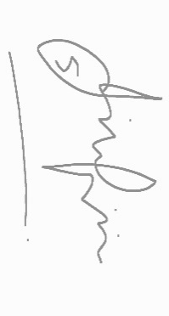 Date: 13 April 2021

(When there is more than one author, only one signature will suffice)

