THE IMPLEMENTATION OF PROJECT-BASED LEARNING TO ENHANCE STUDENTS' READING COMPREHENSION

Fajar Andriansah¹, Peny Fitriyani², Odo Fadloeli³

¹ IKIP Siliwangi
² IKIP Siliwangi
³ IKIP Siliwangi
¹ fandriansah36@gmail.com , ² feny.collection21@gmail.com , ³ odofadloeli@upi.edu

Received: XXXXX X, XXXX; Accepted: XXXXX X, XXXX

Abstract

English is one of the students’ needs to learn. In English there is an important skill that must be mastered that is reading comprehension. Without that, students’ have difficulties in understanding the text, especially narrative text. The researcher conducting Classroom Action Research (CAR) design. The researcher used quantitative and qualitative data were collected. Quantitative data relates to the students’ reading scores in pre-test and post-test. Qualitative data concerns with any occasions and changes happening during classroom activities. The purpose of the research was to figure out whether there is any significant improvement in the students' reading comprehension after being taught by implementing project-based learning. The sample of the research is XI RPL in Vocational High School that consisted of 34 students. The result indicates that the students' reading comprehension of narrative text by using PBL has increased. The improvement covers two points, they are (1) Improvement on students’ mean score. Mean score of pretests was 60.32. score of posttests 1 was 74.19. Which the average score of posttests 2 was 87.42, (2) Students’ reading comprehension was improved. It can be accomplished that there is a significant enhance in the students' achievement after they were taught by project-based learning.

Keywords: Reading Comprehension, Project-Based Learning, Narrative text

INTRODUCTION

English is one of the global languages that the students need to learn. There are four language skills, i. e, listening, reading, speaking, and writing. Reading is one of the significant skills because every activity in the classroom is always related to reading. According to Harmer (2007), reading is a process to understand a written text which means extracting the acquired information from it as efficiently as possible.

Reading is always conducted with comprehension. In accordance with Grabe and Stoller (2002) define reading comprehension as the ability of understanding and interpreting information in a text correctly. Comprehension in reading becomes crucial because it builds the readers to have known what they read. Besides, their reading is not hopeless. Reading comprehension is described as the stage of apprehending of a text. The primary purpose for reading is sometimes overlooked when students’are asked to read difficult text;raising student’s awareness of main ideas in a text and exploring the organization of a text are essential for good comprehension (Richards 2002:277) in Parmawati (2017).

In reality the vocational high school at 4 LPPM Padalarang, the students cannot obtain the aspect of language well. Most of them were still complicated to comprehend an English text. The yield in that their reading comprehension is still at a low level. For this reason the researcher implemented the project-based learning technique for teaching reading.

Project-Based Learning (PBL) is described as an instructional approach that is suitable for the language learning process. In line, Project-based learning is a comprehensive instructional approach to engage students in the sustained, cooperative investigation (Bransford & Stein, 1984). To sum up, PBL provides a connection between groups of learners and gives them some opportunities for thinking, step by step figure out a response and being able to deliver the products in front of the class.

A project is a work where students decide on the process steps, critical aspects, and tasks. This method contextualizes studying by presenting products for students to develop, or synthesize information. And PBL shall become a tool for solving problems that people encounter in real life (Rousova, 2008). The applying of the PBL is to make the learning process conditioned by the following syntax, so as to create communications between teachers and students.

In an application of PBL, there are seven stages in teaching-learning procedures. The seven steps of the PBL model was designed and established by Nizwardi (2017).

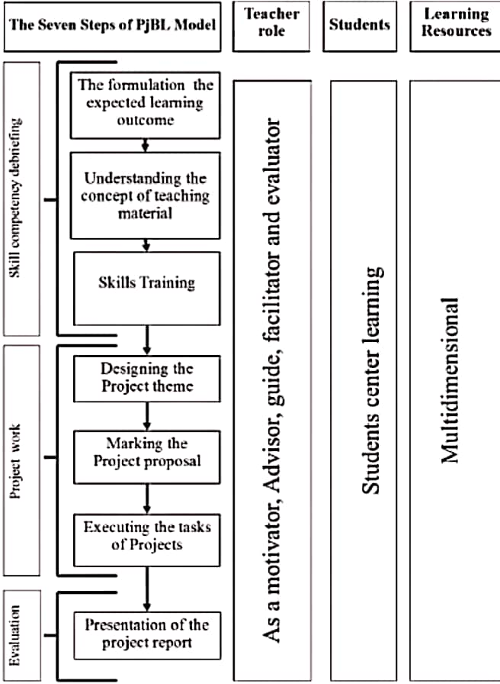

Figure 1. Seven steps of project-based learning

Accordance the figure above it can be shown, in the first step, the formulation of expected learning outcomes, This period delivers information and investigation by the teacher and students' interaction about the acquiring products. Second, understanding the concept of teaching materials, in this view students, must be enthusiastically involved in discussions about their knowledge of the raw material being studied. Third, skills training, students accomplish project assignments based on learning endings and can be done through demonstration and practice. Fourth, designing project themes, the early point of devising, discuss and identify problems. Fifth, making the project proposal, students set down an activity schedule and compose a project task proposal. Sixth, completing the assignments of the project, this phase is practicable actions for students with good collaboration to appoint the quality of performance and realize project design into a real object. Seventh, presentation of the project report, students able to performed for the effort processes and project tasks at the front of the class. That is why the researcher selects this method to raise the students’ reading comprehension. Narrative text helped the researcher in applied project-based learning technique.
Narrative text is a type of text which is studied by students in senior high school level. Brown (2000) stated that at the description of events, for instance, a story, we say that the writer using narration. Narrative text commonly used by people to refer a story in the past. Furthermore, according to Fetzer (2006) narrative text is a story that entertains and/or informs the reader, while carrying a message resulting in a topic and moral.

The researcher is attracted in using narrative texts because the communicative objective of narrative text is retelling the story with complication or problematic. So the text constructs the students curiousity to read and comprehend the text. By using project-based approach technique, the students are able to discuss with their group. Each group worked together to solve the problem and answer the questions from the passage, especially narrative texts.

METHOD

The subject in this research was the second-semester students of the vocational high school at 4 LPPM Padalarang which consisted of 34 students. The method in this study used Classroom Action Research (CAR). According to Wallace (2006) Classroom Action Research (CAR) is a type of method that carried out by the teacher in order to solve problems or to find answers toward context-specific issues. In addition, the teacher or researcher will identify the matters in the class which is related to conditions in learning and then find out solutions to solve the problem in the learning process.

According to Gregory, Kemmis and McTaggart (in Richard and Rodger, 2001), Action research is used to refer to teacher-initiated classroom investigation which seeks to increase the teacher's understanding of classroom teaching and learning, and to bring about changed and develop them in classroom practices. It can be concluded, CAR is a teacher initiative to understand or to figure out the conditions in the classroom.

There are two types of data the researcher was collected. The first one was quantitative data, and the second was qualitative data. Quantitative data relates to the students’ reading scores in pre-test and post-test. Qualitative data concerns with any occasions and changes happening during classroom activities. The researcher collected qualitative data by applying observation and field notes. The instruments in this study used several tests. The tests are pre-test and two post-tests. It was given a multiple-choice, consisting of 30 item questions.

The research brought into two cycles of which each cycle contained some tests, There is a pre-test and post-test. There are seven meetings covered on those two cycles; three meetings for the tests, and four meetings for doing some treatment. In doing treatment the researcher was teaching-learning narrative text with the application of project-based learning.

RESULTS AND DISCUSSION

Results

According to the cases that found out, the researcher has chosen to use project-based learning to increase students’ reading comprehension. The research was carried out for seven meetings at the second-semester of vocational high school level. The seven meetings were categorized into two cycles. The organized processes have four steps for each cycle of CAR, namely: (1) planning, (2) acting, (3) Observing, and (4) reflecting.

Cycle 1: On the planning section, the researcher set up lesson plans to teach the narrative text. The lesson plans were made to be implemented on treatment 1 and 2, which contained the using project-based learning in teaching reading. Move toward the next step, it is acting. In this step, the researcher came to the class four times. The first meeting conducting a pre-test consisted of 30 items. The second and third meetings will be accomplished some treatment. At the last meeting was conducting a post-test. The next stage on CAR is observing. It was done together with the second step. In the the fourth meeting, the researcher provided some observation sheet to capture what the students do in order to ease the process of observing data. The steps of acting and observing are displayed in table 1 below:

Table 1. Meetings in Cycle 1 (1-4)
Number Acting Observing
Meeting | Topic | Activity
1 | Pretest:  Narrative text  The story of Sangkuriang, Cinderella, Malin Kundang, and Blue Tongue Lizard | At the first meeting, the researcher gave the students' pretest consisting of 30 items
2 | Treatment 1:  Narrative text,  Generic Structure | The second meeting, students began to learn about generic structure in narrative text. Then, they discussed some questions allowed by the teacher
3 | Treatment 2:  Narrative text,  Linguistic features | At the third meeting, students learned about linguistic features in narrative text. The teacher was giving a narrative text with a different topic. They tried to find out the linguistic features in groups based on the text given by the teacher
4 | Posttest:  Narrative text  The story of Sangkuriang, Cinderella, Malin Kundang, and Blue Tongue Lizard | In this meeting, the researcher conducted a post-test consisting of 30 items. The questions presented were in the similar level with the pre-test

The last session for the cycle was reflecting. The researcher made some implication from the result of observation during the teaching-learning process. It started from the pre-test. The students confessed that the material in the pretest was hard, They were surprised since they knew very little about the material to deliver. Nevertheless, the pretest was done well by the students, although in the fact there were several students who were still low of the average. The mean score of pre-tests was only 60.32, that score was the minimum score and to pass the grade is must 75.00.

Most of the students have already been taught about the narrative text, but almost all of them were still confused about the concept of narrative text. During treatment 1 and 2, the researcher paid attention to the students working in groups. At the first meeting, students were still confused when given the task to analyze generic structure in narrative text and they were unknown what they have to do. They still needed the teacher's guide to find information in the narrative text.

However, at the final of treatment 2, the researcher noticed that the enjoyment of teamwork started to arise. They begin to be motivated to find information on the teacher instruction. It was followed with the developement of their score post-tests which gain the score of 74.19. From this treatment in cycle 1, it can be drawn there was an advantage and disadvantage during the lesson. The benefit is that students begin to measure their curiosity and motivated to find information and complete their project in narrative text, and the disadvantage is the students still can’t master to comprehend the reading material in the narrative text and they also need the guidance of teachers in doing the tasks. The revision should be accomplished to develop their comprehension of learning and also the mean score.

Cycle II: In this planning session, the researcher established somes repair on the lesson plans. On the previous treatment, the students still were short of mastery to comprehend the reading material, also need the guidance of a teacher in the teaching-learning process. In this cycle, the researcher gave instruction to the students to start making a project inform a paper of narrative text with a different topic. The teacher is a facilitator and directs the students to find the information through gadgets or books about the material of narrative text. They also must make presentations on the final of the project, in measuring their understanding in a narrative text, The teacher gave some questions about that material including generic structure and linguistic features. This strategy was supposed to increase their comprehension in narrative text. Meanwhile, the pre-test used for this cycle was taken from the previous post-test. The cycle can be seen in table 2 below:

Table 2. Meetings in Cycle 2 (5-7)
Number Acting Observing
Meeting | Topic | Activity
5 | Treatment 3:  Narrative text:  Generic Structure and Linguistic Features in a narrative | In this meeting, the students get some instruction to make project paper about narrative text with the teacher chosen topic. First, the students create a group and found the information from books or gadget, second their understanding of the material in the narrative text, then, students start to design their project theme. The teacher observes and as a facilitator the progress of students’ in doing the projects
6 | Treatment 4:  Narrative text, reviewing Generic Structure and Linguistic Features | After the previous meeting, students continued their project. They should be finishing the project. The students get instruction to tell the content of the paper, that is the result of their project. Each group must be presenting their project in front of the class. Then the researcher was giving some questions about generic structures and linguistic features. In the end, the students must answer the questions based on their paper. So, friends may be able to know the generic structure and linguistic features in different stories of narrative text in their project.
7 | Post-Test:  Narrative text  The story of Sangkuriang, Cinderella, Malin Kundang, and Blue Tongue Lizard | In this meeting, the researcher conducted a post-test consisted of 30 items. The questions presented were in the similar level of difficulty with the pre-test

Table 3. Improvement of students' score of the test
 | Pre-Test | Post-Test 1 | Post-Test 2
Minimum score | 25 | 50 | 70
Maximum score | 70 | 90 | 95
Mean | 60.32 | 74.19 | 87.42

Discussion

The research was conducted on two cycles with total meetings were seven; three meetings for the tests and four meetings accomplish the treatment. Each cycle covered the step of planning, acting, observing, and reflecting. From the data assemble by the researcher, The result showed that students' reading comprehension in vocational high school level was increased. The improvements cover two points, they are (1) Improvement on their mean score. Mean score of pre-tests was 60.32, mean score of post-tests 1 was 74.19, while the mean score of post-tests 2 was 87.42. (2) The improvement of their reading comprehension. It can be seen from the increase of their activeness, enjoyment, curiosity, and knowledge.

This research has the aim to improve the students’ reading comprehension using project-based learning, especially in narrative text. As it is shown on the data above there is the improvement of the score reached the target of 75.00, Besides the development of reading comprehension, has been getting the researcher's satisfaction. The application of this technique truly enable to increase students’ reading comprehension.

CONCLUSION

The using of project-based learning helps the students to find out the information from some sources. Also, it increases students’ curiosity in understanding and complete the tasks. It makes them feel free to share about the content that they found themselves without teacher’s instruction. By doing that activity, the students divide up the information, communicate the result and consider the point of view are developed. Besides, the students learn in workgroup give more opportunities to explore their skills in reading comprehension.

Finally, some suggestions from the researcher can be described. In teaching reading, especially narrative text, the teachers must to try many approaches to develop the students' ability and their comprehension. One of the methods is project-based learning. In implementing this method, it needs to be applied appropriately in the teaching-learning process. The procedures of PBL; (1) students formulate the expected learning outcome, (2) they understand the concept of teaching material, (3) they get skills training, (4) they start to design the project, (5) they make the project in groups, (6) they execute the tasks of projects, (7) students’ presentation of the project in front of the class is clear.

Implementing PBL is effectively recommended for the teachers in teaching-learning narrative text. Rather than applying the monotonous method, this technique can be used as an alternative method for the students, so the students are not bored in the learning process. Also it improves the students' reading comprehension, especially narrative text.

ACKNOWLEDGMENTS

First of all, we would like to express our thankfulness to Allah SWT, who has blessed us health, inspiration, and ability so that we could finish this journal. We would like to address our sincere thanks to Dr. H. Odo Fadloeli M.A. and Iman Santoso S.Pd., M.Hum. as our advisor of journal, for their continuous guidance, advice, suggestion, and support. We suppose this journal can be used for other researchers and teachers in teaching reading comprehension. Finally, thanks to Headmaster, English teacher and students' of vocational high school at 4 LPPM Padalarang, who give the facilities. Also, our beloved friends who have given support, advice for doing and finishing this journal. Last but not, we are in debted to Dr. Odo Fadloeli, M.A. who polished the English language of this project.

REFERENCES

Anderson, M & Arderson, K. (n.d.). Text Types in English 2. Australia: Macmillan Education Australia PTY LTD.
Aseptiana Parmawati. (2017). Using Authentic Material To Improve Students’ Reading Interest. Journal ELTIN, 5 NO 2.
Bransford, J., & Stein, B. (1984). The Ideal Problem Solver: A Guide for Improving Thinking, Learning, and Creativity. Newyork: W. H. Freman.

Burnss, A. (2010). Doing Action Research in English Language Teaching. Newyork: RoutLedge.

Grabe, W. & Stoller, F. (2002). Teaching and Researching Reading. London, England: Pearson Education.

Harmer, J. (2007). How to Teach English. England: Longman Pearson.

Lewin, L. (2003). Paving The Way in Reading and Writing: Strategies and Activities to Support Struggling Students in Grade 6-12. San Francisco: Jossey-Brass.

Ningtyas Orilina Argawati. (2014). Improving Students Speaking Skill Using Group Discussion. ELTIN JOURNAL, 2/11.

Nirwardi, J. & R. (2017). The Seven Steps of Project-Based Learning Model to Enhance Productive Competencies of Vocational Students. ATLANTIS PRESS, 102.

Rebecca, J. (2003). A Critical Handbook of Children’s Literature. Massachuset: Pearson Education, Inc.

Rousova, V. (2008). Project-Based Learning. Mazarikova University.

Wallace, M. (2006). Action Research for Language Teachers. Cambridge: University Press.

