IMPROVING STUDENTS’ VOCABULARY MASTERY USING FLASH CARDS

Cucu Rahmawati¹, Kartika Ria Utami²
¹ IKIP SILIWANGI BANDUNG
² IKIP SILIWANGI BANDUNG
¹ cucurahmawati41.cr@gmail.com, ² kartika.u@yahoo.com

Abstract
This research based paper investigates the students’ vocabulary mastery improvement applying flash cards of which the aims are: (1) finding out whether and to what extent the use of flash cards may improve students' vocabulary and (2) describing the weaknesses and the strengths of implementing flash cards to teach vocabulary. The writer conducted a CAR at the eight grade of a junior high in Cilamaya Kulon, This study was conducted in two cycles and conducted in four steps namely; planning the action, implementing, observing, and reflecting. The data of the research were collected by using quantitative collection of data techniques. The result of the investigation noticed that Flash cards could improve the students’ mastery of vocabulary. It can be identified from the mean score of the test which increase from 56.5 in the pretest to 77.1 in the posttest one and 83.7 in the posttest two. The use of flash cards may attract the students’ attention to the lesson well. It also might improve participation of students in learning. They were not shy anymore and really motivated to attend the instructional process.

Keywords: Vocabulary Mastery, Flash Card

INTRODUCTION
English is taught as a compulsory subject for students in Indonesia hoping that the students are able to use it for international communication. Language skills like listening, speaking, reading, and writing as well as language elements such as vocabulary and structure must be taught to the students in all levels. According to (Fries, 1975:38) vocabulary is the essential of language learning that contains the types of vocabulary that is content words in the form of noun, adjective, verb, and adverb which will make language meaningful. In order to be able to use English both in spoken or written language, the students of Junior High school should master the vocabulary. Vocabulary acquisition is crucial to support the students’ mastery of language.
Vocabulary is the main content of language. People use vocabulary to construct a sentence to express the idea. By having a lot of vocabularies, people can express more ideas. Vocabulary achievement is a crucial element in the acquisition of second language. (Wilkins, 1983:3) argues that without grammar little things can be delivered, without vocabularies nothing can be delivered. It means that the ability to speak needs the mastery of vocabulary. The mastery of vocabulary is important in order to build sentences that contains some messages for social interaction. Nevertheless, most students of SMP Negeri 2 Cilamaya Kulon encountered problems in understanding the meaning of words. The students could not speak in English because of their limited vocabularies.
Based on the interview with the teacher, it was found that most of students of SMP Negeri 2 Cilamaya Kulon at second grade lack of vocabulary. The students find difficulties in expressing their idea. The students’ performance are far from the expectation of the curriculum. It can also be seen that their English score is very low. From the researcher’s experience, it was found that most of students could not answer the teacher’s question, they could not answer the question in English. They asked the teacher to translate the question into Indonesian language. Beside that, the other reason that cause the problem was that the teacher did not use the media in learning vocabulary. The teacher just asked the students to read the material and to find the meaning from the dictionary. It made the students feel bored in learning English vocabulary.
Considering the fact above, the teacher should provide the interesting media in order to develop the students’ activity in learning vocabulary. One of the media in teaching vocabulary is flashcard. Flashcard as visual aids is an interesting media that can help the students memorize the words. The colorful picture can attract the students’ attention to learn. It is assumed that if the students are motivated to learn vocabulary, they will enjoy in teaching and learning process. So the students will be easy to communicate with other people in English language. (Weaver, 1950:5) states that learning through visual material will be better than learning through explanation and description. It means that it is possible that flashcard can give good impression on students. It helps the students enjoy the learning activity.
According to the statement above, the researcher focused on the investigating whether there is any improvement of the students’ vocabulary achievement after being taught by using flashcard. It is hoped that flashcard can be used to improve the students’ vocabulary achievement. (Wright, 1968:73) states that flashcard is printed card with words and picture which can be handled easily by the teacher. The teacher can create the flashcard based on the material that will be given.
Flashcard can help the teachers to make the interesting teaching methodology. The researcher considers that the vocabulary on the flashcard is useful for getting new words and their meaning. According to (Lado, 1964:197) flashcard is taken form word of ‘flash’ which means quickly, briefly, instantly, at once, and from the word ‘card’ is piece of stiff paper or thin cardboard, as used for various purposes. It means that flashcard can be very helpful in improving students’ vocabulary and is effective to help the students recall the words that have been learned. Based on the frame theories above, flashcard is a media that can be used to teach vocabulary. Hopefully through this teaching the students will get better in their vocabulary.

METHOD
The researcher used classroom action research as method in this research. (Hopkins, 1983:1) mentions that CAR refers to an act which is undertaken by teachers either to enhance their own or a colleague’s instruction or to test the educational theory assumptions in practice. While Kemmis and McTaggart (in Nunan, 1992:17) claimed that the three defining characteristics of action research are that it is carried out by practitioners rather than outside researchers; secondly, that it is collaborative; and thirdly, that it is aimed to change things. Cohen and Manion, (in Nunan, 1997:18) stated that action research is first and foremost situational, that is concerned with the identification and problem solution in a specific context. They consider collaboration as well as a prominent feature of this type of study, and said that the aim of the action research is improving the current state of affairs within the educational context of which the research is being conducted.
From the above definitions, it can be summarized that action research is a systematic research done by teachers, researchers, headmasters, school counselors, administrator or other educational authorities to solve any problems that have been identified so that getting better improvement.
The model of action research used in this research is the model which is developed by Kammis and Mc Taggart in Burns 2010:7-9). According to them, classroom action research is composed of cycle consisting of four stages namely: plan, action, observation, and reflection.
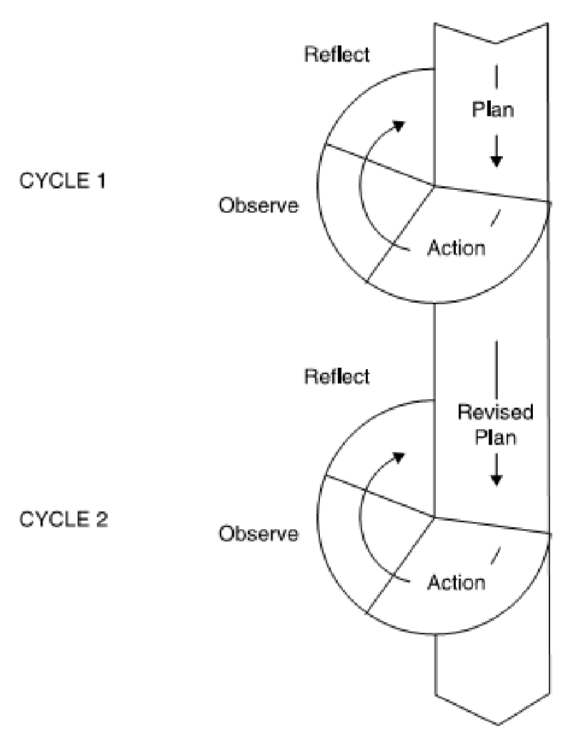
- Planning

After finding students’ problems in learning vocabulary, the researcher designed plans in order to improve their vocabulary mastery. The researcher prepared and planned the materials based on the basic competency, the kind of vocabulary that would be chosen were on the basis of the SD/KD (Standard of Competence and Basic Competency) in the second semester of grade VIII.

- Action
In actions, the researcher taught the students vocabulary using flashcards. The action was carried out into two cycles. The researcher implemented the lesson plans that had been designed in the planning stage. The actions were applied in two cycles, with three meetings for each cycle. It was agreed that the teacher would be the observer and the researcher would do the teaching.

- Observation
In this phase, the researcher made observation notes, and took documentation during the implementation of flashcards in order to improve grade eight students’ vocabulary mastery.
- Reflection

At the end of each cycle, the researcher and the collaborator reflected and evaluated the action. It was done by evaluated the data that had been collected. Then, the researcher and the collaborator determined the actions which were considered as successful. These actions would be maintained in the next cycle, while the less successful actions would be revised to be implemented in the next cycle.

Cycle 1

Planning

After determining the most important and feasible problems to be solved, the researcher determined some actions to solve the problems. The actions were focused on improving the students’ vocabulary mastery using flashcard. Based on the result of the discussion with the teacher of English as the collaborator the action plans of the first cycle were as follows.

- Applying Flashcards to Teach Vocabulary
- Using the Classroom English within the Teaching and Learning
- Communicating the Objectives of the Lessons to the Students
- Asking the Students to Work in Small or Large Groups
- Giving Practice Feedback on the Students’ Pronunciation and Spelling
- Asking the Students to Bring the Dictionary
- Giving Rewards
Action and Observation in Cycle 1

The implementation of the action in the first cycle was done in three meetings. The topic of the first cycle was describing people, and the type of the text was descriptive text. The texts that were used were “My Favourite Idol Nabilla” for the first meeting, “Aliando Syarief” for the second meeting, and “Emma Watson for the third meeting. During the actions, the researcher acted as the teacher and the English teacher acted as the observer.

Reflection

As the plans had been implemented in the action of the first cycle, the teacher and the researcher had a discussion in order to reflect the successful and less-successful actions during the implementation. Furthermore, they evaluated Cycle 1 by analysing the data from the field notes, interview transcripts, and alo observations. Then, they concluded some following reflections as follows.

Cycle 2

Planning

After reflecting the weaknesses and the strengths of the first cycle, the researcher and the teacher agreed to revise some actions to improve the instruction process. The actions which considered successful in the first cycle would be kept while some failed actions would be revised. Thus, they believed that the problems which occurred in the first cycle could be solved. The implementation of the actions in the second cycle was done in three meetings like in the first cycle. The role of the teacher and the researcher remained same as the first cycle. It was the English teacher as the collaborator and observer and the researcher as the teacher in the classroom. The type of the t in texhe set in Cycle 2 was still descriptive text and the topic was describing rooms in the house. The changing of the topic was to make a variation of the materials so the students would not feel bored. The plans for Cycle 2 were explained below.
- Using Flashcards to the teaching of Vocabulary
- Implementing the Classroom English during the process of Teaching and Learning
- Communicating the aims of the Lessons to the Students
- Asking the learners to Work in Small and Large Groups
- Giving Practice Feedback on Pronunciation and Spelling of the students
- Asking the Students to Bring the Dictionary
- Giving Rewards
Action and Observation in Cycle 2

In the second cycle, as planned before, there were two types of flashcards that would be implemented in this cycle. They were the picture-word cards and the word cards as in the first cycle. The students were already familiar with the use of flashcards in the classroom so they followed the flow of the lesson much smoother compared to the first cycle.

Reflection

In Cycle 1, there were some problems during the implementation of the action. Therefore, the researcher and the collaborator formulated the revised action to be implemented in Cycle 2. The result of Cycle 2 became the researcher and the collaborator’s discussion materials to reflect and evaluate the action in Cycle 2. The result of the reflection is presented below.
Regarding to the results of the first and second cyles, the implementation of flashcards in teaching and learning were successful in improving the students’ vocabulary. The use of flashcards made the students more interested in the classroom activities and engaged them to the learning process. The other actions that were implemented in this research also showed a positive result towards the students. The result of the research in improving students’vocabulary mastery is shown in the table 2.

RESULTS & DISCUSSION
Results
The result of the research shows that the use of Flash cards can improve the students’ vocabulary mastery. It can be seen from the mean score of the test which improve from 56.5 in the pre test to 77.1 in the post test one and 83.7 in the post test two. Using flash cards could make the students pay attention to the lesson properly. It also improved students’ participation in learning vocabulary. They were not shy anymore and highly motivated to join the teaching and learning process.

Table 1 : The Improvement of Vocabulary Aspects after Cycle 1
Aspect | Meaning |  | Spelling |  | Pronunciation |  | Word use
 | Pre-  test | Post- test 1 | Pre-  test | Post- test 1 | Pre-  test | Post- test 1 | Pre-  test | Post- test 1
Sumof the score Sum of the students Students' mean  score | 242 | 284 | 192 | 216 | 98 | 250 | 238 | 306
 | 34 | 34 | 34 | 34 | 34 | 34 | 34 | 34
 | 7.12 | 8.35 | 5.65 | 6.35 | 2.88 | 7.35 | 7.00 | 9.00

Table 2 : The Improvement of Vocabulary Aspects after Cycle 2
Aspect | Meaning |  | Spelling |  | Pronunciation |  | Word use
 | Post-  test 1 | Post- test 2 | Post-  test 1 | Post- test 2 | Post-  test 1 | Post- test 2 | Post-  test 1 | Post- test 2
Sumof the score Sum of the students Students' mean  score | 284 | 308 | 216 | 262 | 250 | 260 | 306 | 310
 | 34 | 34 | 34 | 34 | 34 | 34 | 34 | 34
 | 8.35 | 9.06 | 6.35 | 7.71 | 7.35 | 7.65 | 9.00 | 9.12

Discussion
This study aims to improve students' vocabulary mastery by using Flash Cards. Through two cycles, the learning process is carried out and runs well in eight grade students of SMP Negeri 2 Cilamaya Kulon. Based on the scores obtained, in cycle II it has reached the target score. Therefore researchers will not continue to cycle III. It is proven that using this method can improve students' vocabulary mastery.

CONCLUSION
From the explanation above, the researcher concludes that although some weaknesses arise during the implementation of using flash cards, the strengths of using flash cards in teaching vocabulary give benefits more rather than the disadvantages. It is indicated from the improvement of the students’ motivation and achievement.
The improvement of the students’ motivation could be seen from the change of the students’ behavior in the lesson. The students looked so happy when the teacher entered the class. They were very curious with the flash cards that the teacher brought. They waited with full curiosity about what the teacher would do with the flash cards and what they would learn with the flash cards. They also enjoyed the lesson. Besides, the students became so active, enthusiastic and full of participation every time the teacher asked them to guess and answer the question. They were also brave and not shy anymore to pronounce words and to answer the teacher’s questions.

ACKNOWLEDGMENTS
Alhamdulillahirabbil’alamin, thanks to Allah SWT who has enabled to finish this paper. Peace and salutations are always for Rasulullah SAW. Thanks to family and our lecturer during finishing this paper.

REFERENCES
Education, E., Program, S., & Languages, F. O. F. (2017). IMPROVING GRADE EIGHT STUDENTS ’ VOCABULARY MASTERY USING FLASHCARDS AT MTSN GODEAN IN THE ACADEMIC YEAR OF 2016 / 2017.
Fries. (1975). Vocabulary is the essential of language learning.
Hopkins. (1983). To improve their own or a colleague’s teaching.
Lado. (1964). Flashcard is a media that can be used to teach vocabulary.
Manion, C. and. (1997). A similar set of characteristics. Nunan.
McTaggart, K. and. (1992). The three defining characteristics. Nunan.
Taggart, K. and M. (2010). Cycle consisting of four steps planning, action, observation, and reflection. Burns.
Weaver. (1950). Learning through explanation and description.
Wilkins. (1983). States that without grammar little things can be conveyed.
Wright. (1968). States that flashcard and picture can be handled easily by the teacher.

