THE IMPLEMENTATION OF CONTEXTUAL TEACHING LEARNING APPROACH IN TEACHING READING COMPREHENSION TO ANALYTICAL EXPOSITION TEXT
Dendy Aprilian¹, Mundriyah Y Pamungkas²

¹ IKIP Siliwangi
² IKIP Siliwangi
¹ apriliandendy@student.ikipsiliwangi.ac.id, ² mundriy@gmail.com

Abstract

English is a language that is found in all fields of Education, which makes English as a language skill that must be mastered by students. There are four skills in learning English namely; reading, writing, speaking and listening. Reading comprehension is one of the skills which is important to develop by all learners because by reading people can improve their knowledge. The problems were the students had poor vocabulary. The researcher applies (CTL) Contextual Teaching Learning approach, to help students understand English-language reading. The objectives of this research entitled “the implementation of contextual teaching-learning approach in teaching reading comprehension to analytical exposition text” was to found out the implementation of the scenario and the students' responses in teaching-learning reading comprehension. This study used descriptive qualitative as a research design. The subject of this research was the grade XI of students’ senior high school in Cimahi consisted of 20 students. The results of this research showed CTL was successfully implemented based on scenarios prepared by the researchers. Using CTL was able to improve students' motivation in learning reading comprehension. It was expressed by students and teachers in the observation sheets and questionnaires.

Keywords: Contextual Teaching Learning (CTL), Reading comprehension, Analytical exposition.

INTRODUCTION

Language is used as a communication tool by most people in the world. Among so many languages, English is used by people all over the world. This shows that English is widely used to establish communication as an international language. In Indonesia, English is used as one of the subjects taught to students from elementary school, junior high school, senior high school until university level. There are four basic skills- reading, speaking, listening, and writing which should be learn if people want to be able to use the language (Mariani, 2020).
Reading is one of four skills that must be mastered by students in learning English subjects. Having an ability to read a person will find a lot of information from written materials. This statement is supported by who states that Yulianti & Setiawan (2019), reading is the activity of obtaining information through understanding images, shapes, patterns, and rhythms which then gives rise to interpretations which are then understood. Suadiyatno et al., (2020), states that reading is the process of obtaining information authorized by the author, and reading is also one way to get all the information contained therein the text. Sumiati et al. (2019), state that Reading is not only a process of building understanding through symbols and through printed illustration but also a process of building understanding through the reader past experiences. In other words, the purpose of reading is to understand the writer's perception.
Mohamed & Younis (2019), state that reading comprehension is the level of understanding of the text that focuses on the recognition of words which then gives rise to meaning; understanding is the ability to interpret fully what is agreed upon, relating to facts. Sumiati et al. (2019), explain that understanding of special English learning is important with several things; first, believing that reading requires skills performed by students. Second, reading is a reason for achieving success in learning.
During the previous observation that had been done by the researcher in senior high school at XI grade in Cimahi, there were still many students who had poor reading comprehension. Some difficulties why they had poor reading comprehension were the students had a lack of vocabulary, poor grammar structure, and not enough enforcement from the teacher to read intensively and extensively. Those were the students’ difficulties in identifying problems, difficulty in understanding the main point or content of a reading text, most of the students have the problem to understand the meaning of the vocabulary in the text.
According to the phenomena above, the teacher has to solve the problems by providing techniques, approaches, and methods that can motivate students to understand English text. One of the approaches which could be used by the teacher is CTL (Contextual Teaching Learning) approach, as one of the approaches that are expected to help students understand English-language reading. Satriani, et.al (2012:11) cited in Suadiyatno et al. (2020), explain that Contextual Teaching Learning (CTL) is an approach that helps teachers and students connect meaning with real-world situations that are closely related to the material being studied. Whereas Depdiknas (2008: 3) in Suwardini et al., (2018), explain that Contextual Teaching Learning (CTL) is a learning approach that is sourced from daily life so that students can make connections between learning and daily life related to seven main components. The components are namely (a) constructivism (constructivism), the teacher gives a concept of knowledge to students, then students associate new concepts that students already know based on their learning experiences. (b) ask questions (questioning), the teacher encourages students to think critically by giving questions done by students or by the teacher. (c) find (inquiry), observation activities, ask questions, analyze to find information. (d) learning community, problem-solving activities in discussion groups, have goals to solve the problem together, which then manifests mutual respect for opinions. (e) modeling (modeling), give examples before giving assignments and show what needs to problem-solving first. (f) actual level (Authentic Assessment), is a form of description of students to determine student participation in the learning process. (g) reflection, analyzing activity to find out the response to what has been learned.

METHOD

The method used in this study is descriptive qualitative, as mentioned by Gaol et al. (2019), descriptive qualitative research is a data collection technique in scientific research settings to describe phenomena that occur accurately and systematically. Thus the descriptive qualitative data collection has a close relationship with the reality that occurs during activities in the classroom. the subject of the research consisted of twenty students from XI grade. The instruments to collect the data were observation sheets and questionnaires.
These observation sheets were given to the teachers as observers. and the observation was carried out during the teaching-learning process for three meetings with the participation of 20 students as research subjects. There are twenty questions in the observation sheets. Table 1 shows an observation sheet for the teachers as observers.

Table. 1 Observation sheet for the teacher as an observers
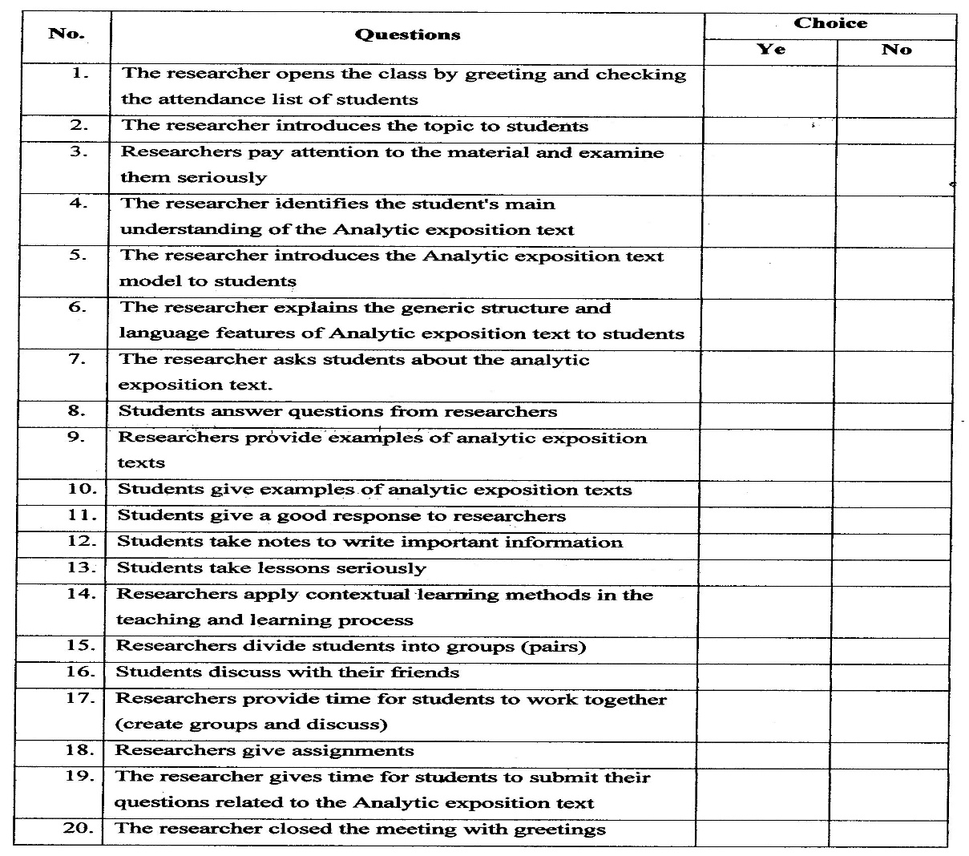
Source adapted from (Muhlisin, 2018)
The questionnaires were given to students at the end of the meetings after all material had been applied. The questionnaires consisted of four indicators; attention, relevance, confidence, and satisfaction). The following is the table of the questionnaires;
Table 2. Students responses Questionnaire
No. | Indicator | No. | Questions | Choice
 |  |  |  | Yes | No
1. | Attention | 1 | Does the learning that has been applied make you have a high willingness to take lessons?
 |  | 2 | Is the learning that has been applied can eliminate the concept of mistakes in you?
 |  | 3 | Does the learning that has been carried out give meaning and make it easier to understand the material?
 |  | 4 | Does learning by this method make it easy for you to understand the material being taught?
2 | Relevance | 5 | Is learning with this method quite interesting, fun, and not boring?
 |  | 6 | Do you feel the time spent understanding this concept is getting shorter?
3 | Confidence | 7 | Are you motivated to get high achievements?
 |  | 8 | Can learning with this method improve your individual critical thinking?
4 | Satisfaction | 9 | Do you feel more valued in expressing opinions while studying?
 |  | 10 | Do you feel more willing to express opinions in the learning process?
Source adapted from (Muhlisin, 2018)

RESULTS AND DISCUSSION

Result

After having analyzed twenty questions raised on the observation sheets it was found as shown table 3.;
Table 3. Observation result
Results of students’ observation checklist
No | Activity | Meeting 1 |  | Meeting 2 |  | Meeting 3
 |  | I | II | I | II | I | II
1 | The researchers open the class by greeting and checking the attendance list of students | √ | √ | √ | √ | √ | √
2 | The researchers introduce the topic to students | √ | √ | √ | √ | √ | √
3 | The researchers pay attention to the material they are studying seriously | √ | √ | √ | √ | √ | √
4 | The researchers identify the student’s main understanding of the Analytic exposition text | √ | √ | √ | √ | √ | √
5 | The researcher introduces the Analytical exposition text model to students | √ | √ | √ | √ | √ | √
6 | The researches explain generic structures and language features of Analytical exposition text to students | √ | √ | √ | √ | √ | √
7 | The researchers ask students about the Analytical exposition texts | √ | √ | √ | √ | √ | √
8 | The students answer questions from researchers | √ | √ | √ | √ | √ | √
9 | The researchers provide examples of analytical exposition text | √ | √ | √ | √ | √ | √
10 | The students give examples of analytical exposition text | − | − | √ | √ | √ | √
11 | The students give a good response to researchers | √ | - | √ | √ | √ | √
12 | The students take notes to write important information | √ | √ | √ | √ | √ | √
13 | The students take lessons seriously | √ | √ | √ | √ | - | √
14 | The researchers apply contextual teaching-learning approach in teaching and learning | √ | √ | √ | √ | √ | √
15 | The researchers divide students into groups (pairs) | √ | √ | √ | √ | √ | √
16 | The students discuss with their friends | √ | √ | √ | √ | √ | √
17 | The researchers provide time for students to work together (create groups and discuss) | √ | √ | √ | √ | √ | √
18 | The researchers give assignments | √ | √ | √ | √ | √ | √
19 | The researchers give time for students to submit their questions related to analytical exposition text | √ | √ | √ | √ | √ | √
20 | The researcher closed the meeting with greetings | √ | √ | √ | √ | √ | √

Note
I | First observation teacher
II | Second observation teacher
√ | Yes
− | No

Based on table 3 the results found by the researcher on the observation sheets conducted by the teachers as an observer showed that at each meeting, all students actively participated in the learning process, the researcher also conducted the learning process used a scenario that was created. At the first meeting based on the results of the observation sheets conducted by the teacher as an observer, the first and second teacher observer state that the researcher open the classroom by greetings and checking student attendants. In addition, the researcher also introduces topics to be studied by students, provides explanations about language features and general structure. At the first meeting, the researcher also asked questions related to the analytic exposition text for students which were then answered by students. However, the first and second teacher observers state that students had been able to give examples of any text that is included in the analytic exposition of the text.
During the second meeting, the first and second teachers as an observer state that the learning process was going well, where the researcher continued the learning process based on the scenario that had been made. This was supported by students who are had been able to understand the material, answer questions correctly, gave examples of text analytical exposition appropriately, create discussion groups, pay attention to the learning process seriously until the researcher closes the learning process activities with regards.
Based on table 3 at the third meetings which were the final learning process, the first teacher and the second teachers as observers state that overall of the learning process which suitable based on the scenario that was made and still involved students to be active and responsive in the learning process. Students begin to get used to the questions asked and answer correctly. Even so at the third meeting, the first teacher as an observer said that some students had not been able to pay attention to the learning process seriously. This was because some students had difficulty in understanding vocabulary in English text. But the implementation carried out by researchers had been going well, and students also could make adjustments in the learning process.
Thus, the results of table 3 observation checklist sheets by the teacher as an observer above, the researcher could be adjusted and applied the Contextual Teaching Learning approach in the process of learning analytical exposition texts. Implementation of the scenario was carried out by researchers arranged systematically started from the opening the class with greetings and checking attendants, introducing the topics to be collected, providing explanations related to the text of analytic exposition; definitions, generic structures, and language features. The researcher gave examples of analytical exposition texts. In addition, students could also actively participate in the ongoing learning process.
The questionnaire used by researchers to see student responses that it was held at the third meeting. The questionnaire consisted of (Yes/No) questions. The question consisted of 4 indicators with a total of 10 questions. While the results of a questionnaire are explained in the following table.
Table 4 the result of questionnaires
Indicator | Question | Yes | No | Total
Attention | 1 | 20 | 0 | 20
 | 2 | 12 | 8 | 20
 | 3 | 20 | 0 | 20
 | 4 | 19 | 1 | 20
Relevance | 5 | 18 | 2 | 20
 | 6 | 15 | 5 | 20
Confidence | 7 | 20 | 0 | 20
 | 8 | 17 | 3 | 20
Satisfaction | 9 | 16 | 4 | 20
 | 10 | 14 | 6 | 20

Base on the table above it can be concluded that at the point of attention indicator on the first question all of the students from 20 students’ mentioned that the learning which had been applied made students have a high willingness to follow the lessons. While for the second question 12 students mention that learning which had been applied could eliminate the concept of exhaustion in students. the third question received responses from 20 students states that learning which had been done gave meaning and made students understand the material easier. The fourth question states that 19 students felt learning by using methods could facilitate students in understanding the material.
From table 4 In the relevant indicator on the fifth question, 18 students gave the response that learning with Contextual Teaching Learning approach which are interesting and fun. In the next question, the sixth question obtained 15 responses from the students who stated that the time spent understanding this concept was getting shorter.
In the confidence indicator, for the seventh question 20 of the students state that students are motivated to get high achievements. In the eighth question, the total responses obtained were 17 students stated that learning with this approach can improve critical thinking patterns of students.
In the Satisfaction indicator, the ninth question there were 16 students stated that students felt more valued in expressing opinions in the teaching and learning process. While the tenth question total responses obtained were 14 students stated that they were more courageous in expressing opinions in the learning process.
Based on the results showed on the table above, it can be concluded of the questionnaire that has been obtained by the researcher, the response from the student’s it can be concluded that the approach that had been applied made students have a high intention to follow the lesson, eliminated the concept of errors in students, made the students easier to understand the material. The use of Contextual Teaching Learning approach could make students more easily understand the material being taught and could motivate students. The students felt more valued in expressing opinions and made students more courageous to express opinions. However, there were still students who had unable to adjust to the approach applied by the researcher. This was closely by their low motivation and their limitation in vocabulary mastery.
Discussion
Based on the results of the analysis conducted by the researcher on observation sheets data conducted by the teachers as an observer, stated that the implementation of the learning process as a whole was based on a scenario that had been made. At the first meeting, the first and second teacher’s observer who stated that the researcher was had been able to open the classroom and, check the presence of students. In addition, the researcher had also introduced the topic to be studied. Emphasize the material related to analytical exposition text such as; definition, generic structure, and language features of analytical exposition text. which are at the first meeting the first and the second teachers as an observer stated that students were had been able to fully provided examples of analytical exposition text. However, the implementation carried out by the first and second teachers as observers stated that the implementation carried out received a good response from students, where students were actively involved in answer the questions raised by researchers and had been able to work together in group discussion.
At the second meeting, the researcher continued the learning process based on the scenario that had been made by the researcher. The first and second observer teachers state that the implementation of the learning process which suitable base on the scenario that had been made, Students remain actively involved in the question-answer process and group discussion. The researcher also prepared examples of analytical exposition text and assignments that would be given to students to present. At the second meeting, the students began to be motivated to the learning process and had been more actively involved in the learning process from the previous meeting.
At the third meeting, in the process of implementation of Contextual Teaching-Learning approach in teaching reading comprehension to analytical exposition text. It was be held based on the scenario that had been made by the researcher, the researcher opened the classroom by greetings and checking the attendance of students, emphasized the material that will be studied, and which has been learned by students. The students could identify problems contained in the text, found the main idea of ​​reading. However, at the third meeting, the first teacher as an observer stated that some students who had not been able to pay attention to the learning process seriously, this was because these students were lacking in the mastering of vocabulary in English so the students felt difficult, but the students were still able to be actively involved and were able to make adjustments in the learning process.
Thus, based on the table 3 Observation checklist by the teacher as observer showed that the implementation of the learning process is appropriate and runs based on the scenarios created. Learning always involves students to be active and think critically about the material presented so that the students had been installed an understanding which the material being taught.
Meanwhile, the response of most students stated that the implementation of learning used the Contextual Teaching Learning (CTL) approach can make the student had been the high motivation to follow the learning process, made the learning process be easier for them to understand the material presented, improve their ability to think critically about phenomena that occur, and students had been mutually express opinions in the learning process. This statement supported by a previous study of Suadiyatno et al. (2020), who states that Contextual Teaching Learning approaches can improve student motivation to learn as well as their reading comprehension.

CONCLUSION

Base on the researcher conducted at eleventh-grade students of Senior High School in Cimahi, the researcher found the answer of the research objective, the researcher concludes that the teaching reading comprehension using contextual teaching-learning approach has shown a positive response from the teacher as observer and students’.
Moreover, teaching reading comprehension using Contextual Teaching Learning approach to help students’ have learned more interesting for students. Students will be attracted and communicative to follow the learning process if the teachers use this approach. Furthermore, using Contextual Teaching Learning approach can show the students reading comprehension. Applying Contextual Teaching Learning approach can also make students enjoy the learning process, actively in the classroom.

ACKNOWLEDGMENTS

First of all thanks to ALLAH S.W.T for His mercy and guidance in giving me the strength to complete this article. The gratitude is delivered to my supervisor for all of this support and guidance in helping me to finish my article. Then, I would like to thanks my parents. At last, I hope that this research can be useful for the reader and other researchers.

REFERENCES

Gaol, Y. D. L., Anzelina, B. S., & Universitiy, P. I. (2019). Teacher’ s strategies in teaching reading at smp swasta mulia pratama medan. 6(2), 249–258.
Mariani. (2020). Implementation Of Lrd ( Listen , Read , Discuss ) Strategy Learning For Increasing Reading Skill and Student Achievement on Discussion Text Material in Class Xii Iik 3 Madrasah Aliyah Negeri 1 Banjarmasin Academic. Jurnal Ptk & Pendidikan, 5(2), 73–81.
Mohamed, M., & Younis, A. (2019). Critical Thinking Magnificence in Teaching Reading Comprehension. 3(4), 39–45. https://doi.org/10.11648/j.tecs.20180304.12
Muhlisin, A. (2018). Analysis of students’response of the implementation of rms (reading, mind mapping, and sharing) learning model in philosophy of science. Unnes Science Education Journal, 7(1), 13–18.
Suadiyatno, T., Firman, E., Hanan, A., & Sumarsono, D. (2020). Examining the Effect of Contextual Teaching- Learning and Anxiety Towards Students’ Speaking Skills. JOLLT Journal of Languages and Language Teaching, 8(1), 100–107. https://doi.org/https://doi.org/10.33394/jollt.v8i1.2266
Sumiati, C., Zulkaidah, D., & Kaswan, K. (2019). Teaching Reading Comprehension Using Jigsaw Technique. PROJECT (Professional Journal of English Education), 2(4), 461. https://doi.org/10.22460/project.v2i4.p461-465
Suwardini, T. D., Sulastri, L., & Altaftazani, D. H. (2018). Application of Contextual Teaching and Learning Model ( CTL ) To Improve Reading Understanding Ability. 01(04), 206–214.
Yulianti, E., & Setiawan, E. (2019). Improving Students’ Reading Comprehension Through Reciprocal Teaching Strategy on Report Text. PROJECT (Professional Journal of English Education), 2(5), 601. https://doi.org/10.22460/project.v2i5.p601-607

