ANALYSIS OF JUNIOR HIGH SCHOOL STUDENTS' MATHEMATICAL CREATIVE THINKING ABILITY ON THE QUADRILATERAL MATERIALS IN THE CITY OF BANDUNG
Hikmal Setiawan¹, Nelly Fitriani²
¹SMK Sangkuriang 1 Cimahi
Hikmalsetiawan98@gmail.com
²IKIP Siliwangi
Nellyfitriani@ikipsiliwangi.ac.id

ARTICLE INFO |  | ABSTRACT
Article history: |  | This research is motivated by the importance of quadrilateral material in mathematics lessons, especially for students as an educational subject in everyday life, while the aim is to analyze students’ mathematical creative thinking abilities in solving quadrilateral problems. This research is a qualitative descriptive study. The population in this study were all seventh grade junior high school students in the city of Bandung whose sample was randomly selected at Paulus Middle School as many as 32 people. Data is obtained by testing creative thinking test questions as many as 4 questions that contain indicators. The results showed that there were 2 people with high ability, 4 people with moderate ability, and 26 people with low ability with various errors including conceptual errors, principle errors, and data operation errors. It can be concluded that students’ creative thinking skills are still relatively low.
Received Jan 01, 2021
Revised Jan 12, 2021
Accepted Jan 15, 2021
Keywords: Creative Thinking
Copyright © 2021 IKIP Siliwangi.
All rights reserved.
 |  | Corresponding Author:
Name of Corresponding Author,
Department of Mathematics Education,
Institut Keguruan dan Ilmu Pendidikan Siliwangi,
Jl. Terusan Jend. Sudirman, Cimahi, Indonesia
Email: author_corresponding@ikipsiliwangi.ac.id
How to Cite:
Fitriani, N., Setiawan, H.(2021). ANALYSIS OF JUNIOR HIGH SCHOOL STUDENTS' MATHEMATICAL CREATIVE THINKING ABILITY ON THE QUADRILATERAL MATERIALS IN THE CITY OF BANDUNG. JIML, X(X), XX-XX.

PRELIMINARY
Mathematics is one of the most important subjects for students to master. Learning mathematics can link concepts and train students’ thinking to be more creative in solving problems logically. A person’s success in studying mathematics can unlock knowledge and creative thinking skills reliably (National Research Council, 1989). Learning mathematics at the elementary, junior high school levels can influence good creative thinking processes if the concepts are applied correctly, so that when high school students already have the ability to think creatively.
Ulandari et al., (2019) say that the ability to think creatively is the ability to produce something that is actual and divergent from others, overcome problems, and determine solutions and reform designs by reviewing problems that might occur and determine rules for handling them so that when it can be implemented properly. In the Indonesian Dictionary, creative is defined as something new or creating, while mathematical is certain or precise. Thus the ability to think creatively mathematically is the ability to think to create new and different things that produce definite and precise answers. The ability to think creatively is needed in today’s era which requires everyone to be more creative, especially in terms of mathematical creative thinking. This is in accordance with ministerial regulation no 22 of 2006 so that students, through school learning can have the ability to think creatively (BNSP, 2006). This explains that the importance of the ability to think creatively in all fields, including in the field of mathematics. Because mathematics is a fundamental science that is very important to learn because every science must contain mathematics in it (Lesi and Nuraeni, 2021).
Tability to think creatively mathematically is very important for students and there must be habituation so that students can easily create creative ideas in teaching mathematics (Faturohman, I and Afriansyah A E, 2020). Then creative thinking must be developed through education in schools, one of which is learning mathematics (Dalilan and Sofyan, 2022).
Torrance (1981) states that there are four creative abilities that can lead to a creative attitude. These abilities consist of fluency, flexibility, originality, and elaboration. These abilities can be learned and practiced by everyone regardless of age.
The ability to think creatively mathematically which is considered so important in fact this ability is still very minimally owned by students as evidenced by the results of research conducted (Dalilan and Sofyan, 2022) mentioning the low ability of students to think creatively mathematically in solving the problems presented, lack of emergence creative ideas, new ideas and alternative answers or other ways.
Based on the previous description, the writer feels the need to analyze the mathematical creative thinking abilities of junior high school students in quadrilateral material. It aims to analyze the extent to which students’ mathematical creative thinking skills in quadrilateral material in the city of Bandung, with the indicators used are fluency, flexibility, originality, and elaboration.
.
RESEARCH METHODS
This study uses a qualitative approach with descriptive methods to obtain an overview of students’ mathematical creative thinking abilities. The research subjects were 32 students including planning, implementing, and observing. Activities at the planning stage are compiling instruments and conducting validation. Activities at the implementation stage are giving students a test of mathematical creative thinking skills regarding quadrilateral material. Activities at the observation stage are analyzing student errors in solving mathematical creative thinking skills questions. Students have good creative thinking skills if they can solve the questions correctly according to Putra (2016). The results of the research were then carried out by a scoring process for each question based on the rubric, so that the total score of each sample was known. Furthermore, the calculation of the average is carried out with the aim of knowing the average percentage of the ability of the sample.
TABLE 1.Table Of Classifying The Average Ability Of Students
Persentage | Classification
0 % | Very low
20 % | Low
40 % | Avarage
60 % | High
80 % | Very high
(Romika & Amalia, 2014)

Table 2.Table of Scoring Creative Thinking ability
Creative Thinking Indicator | Answers | Score
Fluency | No answer | 0
Fluency | Identify several ways of solving different problems | 0-2
Fluency | Determine how to solve the selected problem along with reasons | 0-2
Fluency | Solve problems in a predetermined way | 0-2
Fluency | Solve the problem with another alternative | 0-2
Fluency | Sub-total (one test item) | 0-8
Flexibility | No answer | 0
Flexibility | Identify data/information provided and asked | 0-2
Flexibility | Linking the data/information provided and those asked and constructing a mathematical model of the problem | 0-3
Flexibility | Identify several different ways  to solve the problem | 0-2
Flexibility | Solving the mathematical model of the problem in a predefined different way | 0-3
Flexibility | Compare and explain the best way from several alternative answers accompanied by relevant reasons | 0-2
Flexibility | Sub-total (one test item) | 0-12
Authenticity | No answer | 0
Authenticity | Changing the problem form into another simpler problem form / Modifying the problem | 0-2
Authenticity | Develop a modified mathematical model of the problem in the form of images and or mathematical expressions | 0-2
Authenticity | Identify (non-standard) strategies  for solving problems | 0-3
Authenticity | Complete the mathematical model with the selected non-standard strategy | 0-3
Authenticity | Define relevant solutions | 0-2
Authenticity | Sub-total (one test item) | 0-12
Elaboration | No answer | 0
Elaboration | Identify the known and asked elements/data  of a problem | 0-2
Elaboration | Identify the adequacy of elements/data  and/or complete them | 0-2
Elaboration | Associating elements/data and being asked and compiling a mathematical model of the main problem (images and or mathematical expressions) | 0-3
Elaboration | Breaking down mathematical problems/models into mathematical sub-problems/sub-models | 0-3
Elaboration | Complete the main problem mathematical model accompanied by reasons/explanations of the concepts/processes used at each step | 0-3
Elaboration | Check the correctness of the solution accompanied by reasons | 0-2
The scoring guidelines were used by researchers to group students into three categories, namely students with high abilities(X≥80), avarage abilities (65<X<80),and low abilities (X≤65) (Kurniawan & Setiawan, 2019)

RESULTS AND DISCUSSION
Table 3.Results of Recapitulation of Students' Creative Thinking Ability Test Results
Value range | Total of students | Category | Persentage
X ≥ 80 | 2 | Tinggi | 6,25 %
65 < X < 80 | 4 | Sedang | 12,5 %
X ≤ 65 | 26 | Rendah | 81,25 %
Percentage of Average Ability |  |  | 30.55 %

Table 3 shows that the students’ results on working on questions on the Quadrilateral material and obtained 2 students in the low category with a percentage of 6.25%, obtained 4 students in the medium category with a percentage of 12.5% while 26 students were in the low category in student ability with a percentage of 81.25% with an average of 30.55% which means it is still classified as low ability. The student’s difficulties will be analyzed in the process.
The questions to be used are questions to measure the ability to think creatively with the Dexterity indicator. The form of the question is as follows
“You know a rectangle with a side ratio of 3: 2. If the length is reduced by 2 cm and the width is increased by 3 cm, the rectangle becomes a square. Write down some questions from the data and then solve them?”
The students’ answers to these questions are as follows:
Analysis of errors in student answers on quadrilateral material.
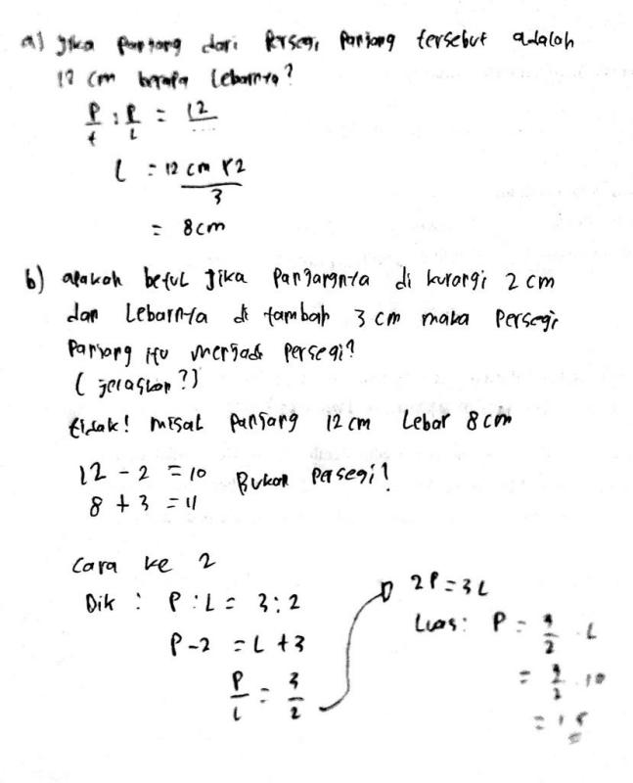
Image 1. Answers of high ability students

Image 1 is the answers of high-achieving students on the problem of creative thinking ability on the flexibility indicator. It can be seen that students have been able to understand the problem by writing down or listing all the information contained in the questions using their own language without being affected by the language of the questions. Then students are able to make completion strategies and carry out these strategies correctly when students calculate the length and area of ​​students work on problems systematically and do calculations correctly. This means that students have understood the concept of quadrilateral material correctly, but students in determining calculations are not explained in detail and are not precise. In this case students fail to understand the concept of calculating the area. Students in calculating the area of ​​the same. This is in line with (Rozi & Afriansyah, 2022) that students’ difficulties in understanding quadrilateral problems lie in conceptual errors.
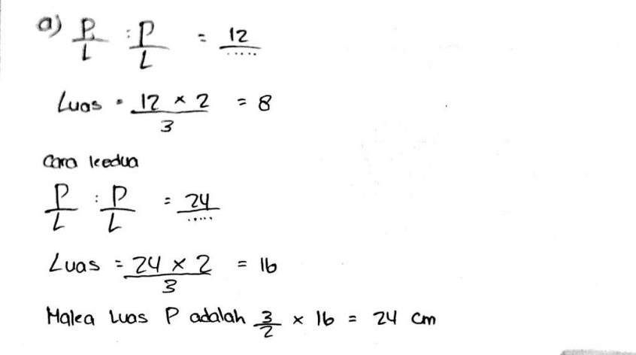
Image 2. Answers of students with moderate abilities

Based on Image 2, which is the answer of moderately capable students, it can be seen that students have understood the problem because they have written down the information contained in the questions using their own language. Students are also able to calculate correctly, but fail to understand the concept of a square. In this case the student makes a principle error, the student immediately adds to calculate the area. The principle error is also one of the mistakes made by students in solving quadrilateral problems (Kamalia & Ruli, 2022). However, students are able to make conclusions by writing conclusions based on calculating the length and area correctly.
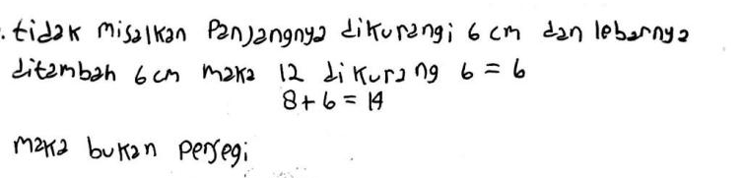
Image 3. Answers of students with low abilities

Based on the picture, it can be seen that students do not understand the problem, students rewrite the language of the questions without summarizing sentences. This means that students do not use their own language in gathering information. In addition, students also paid less attention to the important things contained in the information about the questions. It is proven that when students do calculations, students do not understand the commands and concepts in quadrilateral material in word problems, this is in line with the statement (Alifa and Amir 2022) that one of the student mistakes in working on story-shaped questions is that students do not pay attention to details in information. And have an impact on the results of student workmanship that is wrong.
CONCLUSION
Based on the results of data analysis and discussion, it can be concluded that the ability to think creatively mathematically in grade VII students of Paulus Middle School is still relatively low. This can be seen from the number of students who experience difficulties and errors in solving quadrilateral problems. The forms of errors are quite varied, starting from errors in understanding material concepts, errors in formulating solutions or principle errors, errors in applying formulas, and some students do not pay attention to details in solving problems. As a result, students cannot solve problems correctly and the results are unsatisfactory.
BIBLIOGRAPHY
Alifah, N., & Amir, N. F. A. F. A. Students’ Creative Thinking Ability in Solving Problems in Middle School Triangle and Quadrilateral Materials.
BSNP. (2006). Regulation of the Minister of National Education of the Republic of Indonesia Number 22 of 2006 concerning Content Standards for Elementary and Secondary Education Units.
Dalilan, R., & Sofyan, D. (2022). Middle School Students’ Mathematical Creative Thinking Ability in terms of Self Confidence. Plusminus: Journal of Mathematics Education, 2(1), 141-150.
Faturohman, I., & Afriansyah, E. A. (2020). Improving Students’ Mathematical Creative Thinking Ability through Creative Problem Solving. Mosharafa: Journal of Mathematics Education, 9(1), 107-118.
Kamalia, N. A., & Ruli, R. M. (2022). ANALYSIS OF JUNIOR HIGH SCHOOL STUDENTS’ MATHEMATICAL CREATIVE THINKING ABILITY IN FLAT BUILDING MATERIALS. Journal of Mathematics Education and Science(JES-MAT), 8(2), 117-132.
Kurniawan, A., & Setiawan, D. (2019). The Effectiveness of the Inquiry Learning Model on Students' Creative Thinking Ability in Pythagorean Theorem Material. Journal Scholar: Journal of Mathematics Education,2(5), 271–282.
Lesi, A. N., & Nuraeni, R. (2021). Differences in Students’ Mathematical Problem Solving Ability and Self-Confidence between the TPS and PBL Models. Plusminus: Journal of Mathematics Education, 1(2), 249-262.
National Research Council. (1989). Everybody Counts. A Report to the Nation on the Future of Mathematics Education. Washington: National Academy Press.
Romika & Amalia, Y. (2014). Analysis of Students’ Mathematical Problem Solving Ability on Flat Sided Space Construct Material with Van Hiele Theory. Bina Gogik,1(2), 17–31
Rozi, F. A., & Afriansyah, E. A. (2022). Analysis of mathematical creative thinking abilities based on students’ mathematical dispositions. Journal of Authentic Research on Mathematics Education (JARME), 4(2), 172-185.
Torrance, P.E. (1981). A Three-Stage Model Teaching for Creative Thinking. Dalam A. E. Lawton (Editor) Science Education Information Report. Columbus, Ohio: The Eric Science, Mathematics and Environmental Education Clearing House, 226-253.
Torrance, P.E. (1981). A Three-Stage Model Teaching for Creative Thinking. Dalam A. E. Lawton (Editor) Science Education Information Report. Columbus, Ohio: The Eric Science, Mathematics and Environmental Education Clearing House, 226-253.
Ulandari, N., Putri, R., Ningsih, F., & Putra, A. (2019). The Effectiveness of the Inquiry Learning Model on Students’ Creative Thinking Ability in Pythagorean Theorem Material. Scholar’s Journal: Journal of Mathematics Education, 03(02), 227–237..

