Journal of Innovative Mathematics Learning ISSN 2621-4733 (print) Volume 2, No. 3, September 2019 ISSN 2621-4741 (online)

EFFORTS TO INCREASE THE MATHEMATICAL UNDERSTANDING ABILITY OF CLASS V STUDENTS IN SDN 3 BATUJAJAR
IN THE SOLID NUMBERS MATERIALS USING CONSTRUCTIVISM APPROACHES

Layla Sa’adah
IKIP Siliwangi Bandung
layla.saadah2015@gmail.com

Received: Jul 20th, 2019; Accepted: Sept 21st, 2019

Abstract
The method in this study is the Classroom Action Research (CAR) method. PTK consists of four stages, namely planning, action, observation and reflection. PTK is carried out through 3 cycles of 6 meetings. Learning instruments consist of questionnaires, observation sheets of student activities, interview sheets, Student Worksheets (LKS) and evaluation sheets. The result of the implementation of PTK is an increase in mathematical comprehension and teacher and student activities from the first cycle to the third cycle. Teacher activities are more increasing than learning as usual, with the constructivism approach applied by the teacher acting as a facilitator, motivator and mediator for students. The increase in the ability of mathematical understanding and student activity is indicated by changes in scores and changes in scores of students who reach the KKM from the first cycle to the third cycle in a row namely 48.6%, 64.9% and 81.1%.
Keywords: Constructivism, Mathematical Understanding Ability, Fraction Addition

Abstrak
Metode dalam penelitian ini adalah metode Penelitian Tindakan Kelas (PTK). PTK ini terdiri atas empat tahapan yaitu perencanaan, tindakan, observasi dan refleksi. PTK dilaksanakan melalui 3 siklus 6 pertemuan. Instrumen pembelajaran terdiri dari angket, lembar observasi kegiatan siswa, lembar wawancara, Lembar Kerja Siswa (LKS) dan lembar evaluasi. Hasil dari pelaksanaan PTK adalah terjadinya peningkatan kemampuan pemahaman matematik dan aktivitas guru dan siswa dari siklus pertama sampai siklus ketiga. Aktivitas guru lebih meningkat daripada pembelajaran seperti biasanya, dengan pendekatan konstruktivisme yang diterapkan guru berperan sebagai fasilitator, motivator dan mediator bagi siswa. Peningkatan kemampuan pemahaman matematik dan aktivitas siswa ditunjukkan dengan perubahan skor dan perubahan skor siswa yang mencapai KKM dari siklus pertama sampai siklus ketiga berturut-turut yaitu dari 48,6%, 64,9% dan 81,1%.
Kata kunci:Konstruktivisme, Kemampuan Pemahaman Matematik, Penjumlahan Pecahan

How to Cite: Saadah, L (2019). Efforts to Increase the Mathematical Understanding Ability Of Class V Students in SDN 3 Batujajar In The Solid Numbers Materials Using Contructivism Approaches. JIML, 2(3), 131-136.

131

INTRODUCTION
Mathematics has an important role in addition to other subjects, because mathematics has a function to develop the ability to reason students through the activities of inquiry, exploration and experimentation as a tool to solve problems through thought patterns related to the mathematics material itself or related to other subjects which requires elements of mathematical thinking patterns. In addition, mathematics must also be able to solve problems faced by students in their daily lives.
One of the learning materials for mathematics in grade V elementary school is fraction counting operations. This material is one of the main material that elementary school students must master because it will be useful for daily life. But the reality obtained in the classroom, the results obtained by students after learning fraction counting operations are not optimal. In general, there are still many students who have difficulty in understanding this material.
In teaching activities at school, the writer found one of the slowness of learning in fifth grade students. Of the total number of 37 students, only 19 people were able to work on the problems. Likewise, after the remedial was held, there was no change in the results of the fractional count operation.
Based on the results of this preliminary study, it turns out that one of the factors that causes the low understanding of students in mathematics, is because students are afraid to ask teachers about the mathematical problems they face. In addition, some students are lazy to develop thoughts, do not want to know and do not want to try in learning mathematics. Factors of lack of media use and the selection of strategies that are fun by the teacher also make it difficult for students to understand the material. This is as seen in table I in the form of student learning outcomes data on learning data processing in the past years.

. Table I
List of Mathematics Values ​​for Calculate Operations for Class V SDN 3 Batujajar
No | Years of study | Many students | Total score | Average Score
1 | 2016/2017 | 50 | 3050 | 61
2 | 2017/2018 | 47 | 2914 | 62

According to Karli and Margaretha (in Sa'adah, 2010) actually when the teacher explains a material to students, the teacher does not need to bother cramming new knowledge / material in the way above, because students already have life experiences in themselves as initial conceptions. In order for students to gain meaningful learning, in class students must be empowered to explore the knowledge that exists in themselves. Students are given the opportunity to share coping strategies, debate one another and think critically about the best way to solve each problem (Kostaman, 2008: 3).

In an effort to overcome these problems in order to achieve the expected goals, the authors argue that what needs to be improved in this learning process is an effective learning approach and media in learning fraction counting operations. The learning approach that will be used by the writer in this research is the constructivism approach because the constructivism approach is an approach where students build their own knowledge little by little and not suddenly so that the concept of fraction counting operations can be remembered.

The author tries to conduct classroom action research using a constructivism approach that emphasizes the quality of student-oriented learning. This research rejects teacher-oriented learning where every student learning mathematics (elementary school) is not treated to ready-made formulas, because this will fetter student thinking. Each student is given the opportunity to solve the problem of adding fractions to the knowledge structure that they built themselves

METHOD
This research was conducted using the classroom action research method which is often called classroom action research. According to Hopkins (In Law, 2008: 5) that "Classroom action research is research that combines research procedures with substantive action, an action carried out in the discipline of inquiry or an attempt by someone to understand what is happening while engaging in a process of improvement and change. ". This class action research was conducted in class V SDN 3 Batujajar, Batujajar District, West Bandung Regency. The research subjects were 37 class V students consisting of 18 female students and 19 male students. The test instrument in this study is an understanding ability instrument. This research procedure consists of three cycles where each cycle consists of two actions. At the end of each cycle given a test, then the test results will be analyzed based on the level of difficulty of students

RESULTS AND DISCUSSION
Mathematical Understanding Ability from Cycle One to Cycle Three
The students' mathematical understanding abilities measured in this study include indicators: a) Restate a concept; b) Classifying certain objects according to the concept; c) Give examples and not examples of concepts; d) Presenting concepts in various forms of mathematical representation; e) Developing the necessary or sufficient conditions of a concept. Minimum completeness criteria (KKM) for Mathematics class V is 72.
In cycle 1 students who achieved the KKM score amounted to 18 students from 37 students with the percentage of grades that reached the KKM was 48.6%. In cycle II, there were 24 students who achieved the KKM score with the percentage of grades that reached KKM was 64.9%. Whereas in the third cycle, there were 30 students who achieved the KKM score with the percentage of grades that reached KKM was 81.1. The following is an increase in the percentage for each cycle:
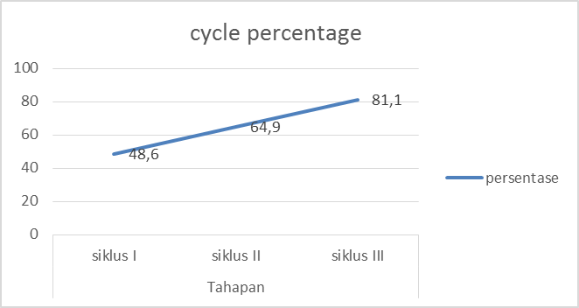
percentage
cycle I cycle II cycle III
stage

Picture 2 : cycle percentage

Student Performance from Cycle One to Cycle Three
Teaching and learning process in the first cycle is done by conventional learning, where the teacher explains the subject matter with the lecture and question and answer method, students listen to the teacher's explanation. In cycle I, the teacher who played an active role, the role of students was still less visible from the activities of students when asking questions and issuing their opinions. Students do not seem to fully understand the material being studied, especially when presented examples of questions in the form of description, only a few students who raise their hands and are willing to finish it on the board

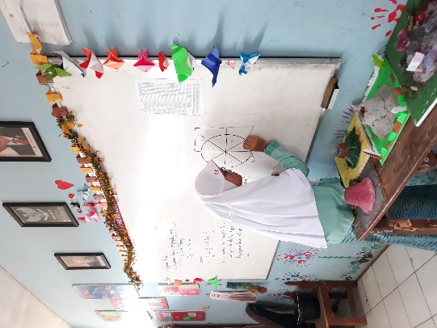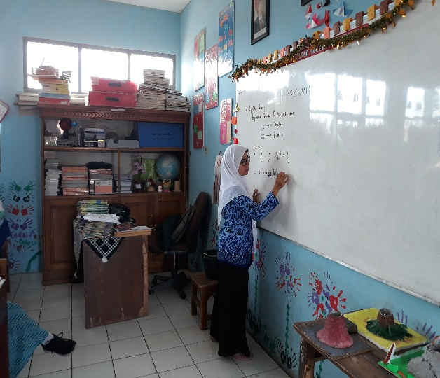
Picture 3. student performance cycle I
In cycle II, the teaching and learning process is carried out using a constructivism approach, where students construct their own knowledge. As stated by Suciati et al (2016) the constructivism approach in the world of learning is associated with constructing or shaping meaning from the learning experiences lived by students, that knowledge is shaped by students based on the experiences they have lived in and not given by the teacher. In other words through the constructivism approach students are required to play an active role in the learning process, students sit in groups to conduct discussions and experiments to solve the problems presented by the teacher as a facilitator. The ability to understand can be seen when students can solve mathematical problems.
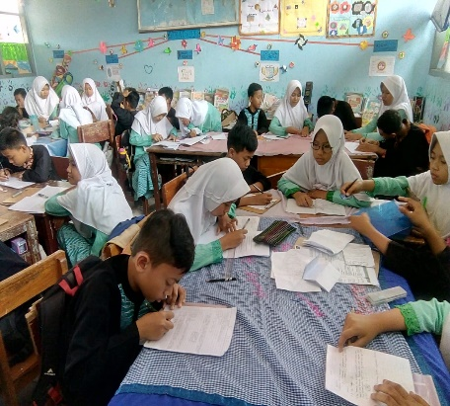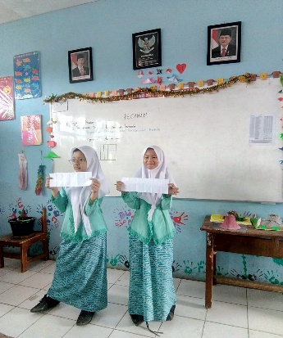
Picture 4. student performance cycle II
During the learning process, students were seen to be more enthusiastic than cycle I. Students were enthusiastic in completing the worksheets provided by the teacher in groups, they discussed. When facing difficulties, they do not hesitate to ask the teacher. After the group discussion is over, representatives of each group present their group work in front of the class.
In the third cycle, still using the constructivism approach but with different material. Students in groups complete their group worksheets. Like in picture 4 below.
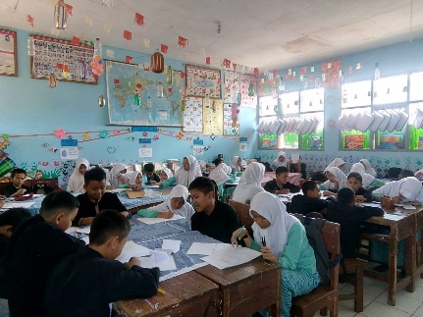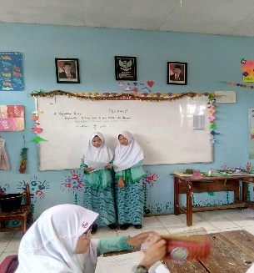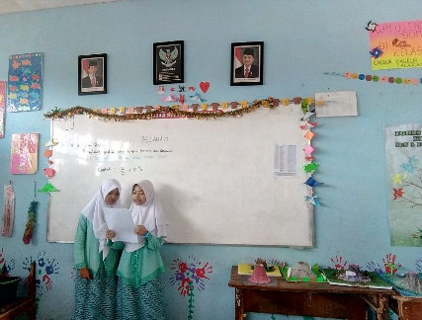
Picture 5. student performance cycle III

Here it can be seen that students who already understand the concept of the material will have no difficulty when solving mathematical problems presented by the teacher in the form of group work, students can solve the problems presented by the teacher through Worksheets based on the knowledge they have previously possessed correctly. In line with the opinions of Hendriana, Rohaeti and Sumarmo (2017) Mathematical understanding is a basic competency in mathematical learning which includes: the ability to absorb a material, remember mathematical formulas and concepts and apply them in similar cases, estimate the truth of a statement, and apply formulas and theorems in solving problems

CONCLUSION
Based on the exposure and data obtained shows an increase from cycle I, II and III. The results of the first cycle evaluation test have not yet seen significant changes because they still use ordinary learning. In the second cycle, changes began to appear after using the contextual approach, as well as in the third cycle still using the contextual approach, only the material is different.
In addition to using the approach, the learning process is also added using LKS so that there is also an increase in student activity during the learning process Based on data processing and findings obtained in this class action research, it can be concluded that: The ability of students' mathematical understanding from cycle to cycle shows an increase in views from the acquisition of student grades that reach the KKM limit. Student performance in each cycle also increases, both in discussions, ask and solve problems given by the teacher, the difficulty of students in the material operation of fraction addition contained in the material addition of the fractions are not the same and the sum of mixed fractions, the difficulty of students in the evaluation cycle of the least cycle on the indicator presents the concept in various forms of mathematical representation and the indicator develops the necessary conditions or sufficient conditions of a concept, There is a change in the value of each cycle, the increasing value reaches above the Mathematics KKM, so that this class action research using a contextual approach can be concluded successful

ACKNOWLEDGMENTS
We thank the Principal and teaching staff at SDN 3 Batujajar for giving us the opportunity to carry out this class action research. Also to the lecturer in mathematics education research methods namely Dr. H. Euis Eti Rohaeti, M.Pd and Anik Yuliani, M.Pd who have guided us in completing this article

REFERENCES
Hendriana, Heris, Euis Eti Rohaeti Dan Utari Sumarmo. (2017). Hard Skills Dan Soft Skills Matematik Siswa. Bandung: PT. Refika Aditama.
Kostaman. (2008). Pendekatan Konstruktivisme dapat Meningkatkan Pemahaman Siswa dalam Konsep Bilangan Pecahan untuk Kelas V SD. Skripsi Sarjana Pendidikan pada FIP UPI Bandung: tidak diterbitkan.
Sa’adah, L. (2010). Pendekatan Konstruktivisme untuk Meningkatkan Pemahaman Siswa tentang Penjumlahan Pecahan. Skripsi pada FIP UPI. Bandung : Tidak Dipublikasikan
Suciati, dkk. (2016). Integrasi Teori dan Praktek Pembelajaran. Tangerang : Universitas Terbuka.
Undang, Gunawan. (2008). Teknik Penelitian Tindakan Kelas. Jakarta: Sayagatama

