FACTORS AFFECTING MATHEMATICS PROBLEM SOLVING ABILITY IN ONLINE LEARNING
Azhar Majid Hidayat¹, Al Jupri², Dadang Juandi³
¹Pendidikan Matematika, Universitas Pendidikan Indonesia, Jl. Dr. Setiabudi No.229, Isola, Kec. Sukasari, Kota Bandung, Jawa Barat 40154, Indonesia
azharmajidh@upi.edu
²¹Pendidikan Matematika, Universitas Pendidikan Indonesia, Jl. Dr. Setiabudi No.229, Isola, Kec. Sukasari, Kota Bandung, Jawa Barat 40154, Indonesia
aljupri@upi.edu
³¹Pendidikan Matematika, Universitas Pendidikan Indonesia, Jl. Dr. Setiabudi No.229, Isola, Kec. Sukasari, Kota Bandung, Jawa Barat 40154, Indonesia
dadang.juandi@upi.edu
ARTICLE INFO |  | ABSTRACT
Article history: |  | Absract: This study aims to determine the factors that affect online learning of class XI students on their mathematical problem-solving abilities. This research uses descriptive qualitative research methods. The population in the study was simultaneously used as a sampling (Total Sampling) with a total of 52 students. Data were collected through tests and questionnaires. Based on the results of research on the mathematical problem solving ability of students at one of the senior high schools (SMA) in the city of Bandung in online learning 50% has a medium category, so that online learning is going well, the problem only occurs in indicators checking and testing calculations or solutions. Internal factors and external factors have a strong influence during online learning.  Abstrak: Penelitian ini bertujuan untuk mengetahui faktor-faktor yang mempengaruhi pembelajaran daring peserta didik kelas XI terhadap kemampuan pemecahan masalah matematis. Penelitian ini menggunakan metode penelitian kualitatif deskriptif. Populasi dalam penelitian sekaligus digunakan sebagai sampling (Total Sampling) dengan jumlah 52 peserta didik. Data dikumpulkan melalui tes dan angket. Berdasarkan hasil penelitian kemampuan pemecahan masalah matematis peserta didik salah satu Sekolah Menengah Atas (SMA) di Kota Bandung dalam pembelajaran daring 50% memiliki kategori sedang, sehingga pembelajaran daring terbilang lancar, permasalahan hanya terjadi pada indikator memeriksa dan menguji perhitungan atau penyelesaian. Untuk faktor internal dan faktor eksternal memiliki pengaruh yang kuat selama pembelajaran daring berlangsung.
Received Jan 01, 2021
Revised Jan 12, 2021
Accepted Jan 15, 2021
Kata Kunci:
Mathematics Problem Solving
Internal Factors and External Factors
Online Learning

Copyright © 2021 IKIP Siliwangi.
All rights reserved.
 |  | Corresponding Author:
Name of Corresponding Author,
Department of Mathematics Education,
Institut Keguruan dan Ilmu Pendidikan Siliwangi,
Jl. Terusan Jend. Sudirman, Cimahi, Indonesia
Email: author_corresponding@ikipsiliwangi.ac.id
How to Cite:
Hidayat, A. M., Jupri, A., Juandi, D. (2021). Factors Affecting Mathematics Problem Solving Ability In Online Learning.

INTRODUCTION
At the beginning of February 2020, Indonesia was shocked with the news that there were people who were exposed to the Coronavirus Disease (Covid-19). This virus can survive more than 10 minutes on surfaces, including hands. Even the World Health Organization (WHO) says the new corona virus (Covid-19) can last for several hours, even days and can survive at temperatures of 26-27 degrees Celsius (Zahrotunnimah, 2020). Covid-19 has been declared a pandemic by WHO so that it has an impact on education in Indonesia.
In March 2020, Minister of Education and Culture (Mendikbud) Nadiem Anwar Makarim said that Circular Letter Number 3 of 2020 concerning Prevention of COVID-19 was a guide in dealing with the disease at the education unit level. The Ministry of Education and Culture also appeals to the education unit to postpone activities that gather a large number of people (teaching and learning activities) or activities outside the education unit (camping, study tours). (Kemdikbud, 2020) with this statement, face-to-face learning (offline learning) was stopped for several weeks, until finally learning turned into an online learning method.
Online learning or previously known as e-Learning is learning that delivers material through gadgets. By using these gadgets, there are several applications that can help teaching and learning activities, such as whatsapp, zoom, web blog, edmodo, etc. The government also takes a role in dealing with inequality in learning activities during the COVID-19 pandemic. Launching the official website of the Indonesian Ministry of Education and Culture, there are 12 platforms or applications that students can access to study at home, namely (1) learning houses; (2) Our table; (3) Icando; (4) Indonesiax; (5) Google for education; (6) Smart class; (7) Microsoft office 365; (8) Quipper school (9) Teacher's room; (10) Your school; (11) Zenius; (12) Cisco webex. (Handarini & Wulandari, 2020). In using these applications, the teacher chooses the most suitable application for online learning during learning activities, especially learning mathematics which is different from learning other subjects.
Learning mathematics as one of the important learning as a science that becomes the basis for other sciences. According to Permendiknas No. 22 of 2006, learning mathematics aims for students to have the ability: (1) understanding of mathematical concepts, explaining the relationship between each concept and the application of algorithms or concepts in a flexible, precise and accurate way in problem solving, (2) reasoning on patterns and characteristics, manipulating mathematics in compiling generalizations, compiling evidence, and or explanations related to mathematical questions and ideas, (3) problem solving consisting of understanding the problem, designing and completing mathematical models, and interpreting the solutions obtained, (4) the use of symbols, diagrams, tables or others in conveying ideas to describe the problems or conditions found, (5) an attitude that appreciates the benefits of mathematics in every aspect of life (Permata & Sandri, 2020).
In addition, according to the National Council of Teachers of Mathematics (NCTM) in 2000 stated that there are five standards that describe the relationship between understanding mathematics and mathematical competence that students should know and can do. "Understanding, knowledge and skills that students need to have are included in the standard process which includes: problem solving, reasoning and proof, communication, connections and representation" (Hudiono, 2005).
The government and NCTM state that problem solving is one of its goals. Therefore, mathematical problem solving ability is one of the main focuses in learning mathematics. So that in learning mathematics, students must be properly facilitated to develop their abilities optimally. Problem solving skills are an important part of learning mathematics. The importance of problem solving skills by students in mathematics is also emphasized by Branca (Syaiful, 2012),
1. The ability to solve problems is a general goal of teaching mathematics, even as the heart of mathematics.
2. Problem solving which includes methods, procedures and strategies is the core and main process in the mathematics curriculum.
3. Problem solving is a basic ability in learning mathematics.
From these points, Syaiful (2012) said that problem solving skills should be possessed by all children who study mathematics from elementary school to university. Polya (1973) proposed four steps in solving mathematics problems. The steps are 1) understanding problem, 2) devising a plan, 3)carrying out the plan, and 4) looking back.
Online learning is a new thing for the world of high school level education. Because something new must have some obstacles. In addition, students have learning difficulties by adapting to online learning. Mulyadi (2010: 6) states that learning difficulties are a condition in learning that is characterized by certain barriers to achieving learning outcomes. Then according to Blassic and Jones (Irham & Wiyani, 2013), learning difficulties experienced by students indicate a gap or distance between the expected academic achievement and the academic achievement achieved by students in fact. So that the adjustment of students in adjusting to online learning must be minimized by knowing several factors that affect learning difficulties.
Ahmadi and Supriyono stated that there are two factors that cause learning difficulties, namely internal factors and external factors. Internal factors are physiological factors (physical condition of students) and psychological factors (psychological conditions of students). External factors come from outside the students themselves, namely family, school, and community factors (Cahyono, 2019). One of the internal factors is influenced by the psychology of students which includes (1) intelligence, (2) attention, (3) interest, (4) talent, (5) motivation and (6) readiness. While external factors include (1) family aspects, (2) school aspects and (3) community aspects. (Hapnita, 2018).
Based on this, the study aims to determine the mathematical problem-solving ability of students in online learning. In addition, knowing the internal factors and external factors that affect students' mathematical problem-solving abilities in online learning.

METHOD
This research method uses descriptive qualitative research methods. Descriptive research (Arikunto, 2010) is a study that aims to determine the circumstances and conditions in which the results are described in the form of a research report. Subjects of this research were the students of class XI SMA Negeri 5 Bandung, totaling 52 students. The instruments used in this study were (1) Test, (2) Questionnaire.
The type of test used in this study is a subjective test (form of description). The form of subjective type test questions is a description form. This is because to answer these questions, students are required to compile answers in a detailed, systematic, and detailed manner. In addition to having to really master the test material, in this test students are required to be able to express it in written language well, the thought process will be clearly visible in the answers (Suherman, 2011). Mathematical problem-solving ability test consisting of 3 questions describing the application material for the derivative of algebraic functions with their indicators.
The problem-solving ability score is adapted from Prabawanto (in Nurzaman, 2015) and is presented in Table 1 as follows:
Table 1. Criteria for Mathematical Problem Solving Ability Score
No. | Student Response | Score
1. | There is no solution and does not show understanding of the problem | 0
2. | Wrong answer or no solution but shows understanding of the problem | 2
3. | The answer is wrong or not complete, part of the completion process shows the right direction | 4
4. | Correct answer, the completion process is irrelevant | 6
5. | Correct answer, relevant resolution process, but less clear. | 8
6. | Correct answer, relevant and clear resolution process | 10
Researchers classify the results of students' mathematical problem solving ability tests adapted from Nurzaman (2015) which can be seen in Table 2 below:
Table 2. Classification of Mathematical Problem Solving Test Results
No. | Score Range | Category
1. |  | High
2. |  | Medium
3. |  | Low
4. |  | Very low
Questionnaires are used to determine internal factors and external factors on online learning. The questionnaire compiled by the researcher is a closed questionnaire in the form of a Likert scale. Each statement in this research questionnaire has five alternative answers, namely Strongly Agree (SS) score 5, Agree (S) score 4, Disagree (TS) score 2, and Strongly Disagree (STS) score 1, which consists of 20 questions with 9 indicators as shown in table 3. The score is calculated by adding up the weighted scores for each question item. Then the data is presented by using the calculation formula. The formula used (Riduwan & Akdon, 2009) is:
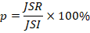
Information:
p : percentage of answers
JSR : total score of respondents
JSI : ideal score

Table 3. Questionnaire Grid of Factors Affecting Online Learning
No. | Factors | Indicator | Nomor Item
1. | Internal | Intelligence | 1 (+), 2 (-)
2. | Internal | Attention | 3 (+), 4 (+)
3. | Internal | Interest | 5 (+), 6 (-)
4. | Internal | Talent | 7 (+), 8 (-)
5. | Internal | Motivation | 8 (+), 10 (-)
6. | Internal | Readiness | 11 (+), 12 (+)
7. | External | Family Aspect | 13 (+), 14 (-), 15 (-)
8. | External | Community Aspect | 16 (+), 17 (-), 18 (+)
9. | External | School Aspect | 19 (+), 20 (+)
After that, the interpretation is carried out using the criteria of Riduwan & Akdon (2009) as follows:
Table 4. Interpretation of Questionnaire Percentage
No. | Percentage | Interpretation
1. |  | Very poor
2. |  | Poor
3. |  | Average
4. |  | Good
5. |  | Excellent
RESULTS AND DISCUSSION
Based on the results of student responses to the mathematical problem-solving ability test that has been shared through google classroom related to online learning during the Covid 19 pandemic at a high school in Bandung, in general, it is presented in Table 5.

Table 5. Mathematical Problem Solving Ability Test Results
Indicator | Category
Indicator | Very Low | Low | Medium | High
1 | 2% | 6% | 2% | 90%
2 | 12% | 10% | 40% | 38%
3 | 10% | 19% | 25% | 46%
4 | 50% | 33% | 15% | 2%
Total | 8% | 19% | 50% | 23%

Information:
Indicators of Mathematical Problem Solving Ability:
(1) Understanding problem,
(2) Devising a plan,
(3) Carrying out the plan, and
(4) Looking back.
Based on the results of the students' mathematical problem solving ability test on the application material of the derivative of algebraic functions in online learning, the most prominent of the indicators is "understanding problem" with the category "High" with a percentage of 90% so that students do not have difficulty in understanding the problem in story questions about application of differential algebraic function. While the indicator "devising a plan " stands out in the "Medium" 40% and "High" 38% categories, this shows that in planning for alternative solutions to problems, students can still find them well.
Furthermore, the indicator "carrying out the plan" has a "High" category with a percentage of 46% stating that almost half of students can perform calculations from the plans they made. While others there are errors or lack of accuracy in doing calculations. And for the last indicator, "looking back" has a "Very Low" category with a percentage of 50%, which is half of students experiencing problems in this indicator. It indicates that students have difficulty in checking the results of the calculations that have been obtained.
Overall indicators on the mathematical problem solving ability of students 8% have a very low category, 19% in the low category, 50% in the medium category and 23% in the high category. This shows that the students' mathematical problem solving abilities using online learning are mostly in a fairly good category and can be understood by students.
The results of the written test of problem-solving abilities in the very low category that have been carried out show poor results. The following will analyze the results of the written test of problem-solving abilities that have been carried out in solving the questions.
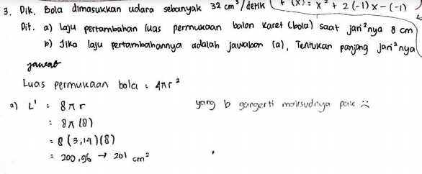
Figure 1. Results of Student Completion in Very Low Category
Based on the written answers written in Figure 1, it can be seen that students are only able to understand the problem by stating what is known and asked in the question.
The results of the written test of problem-solving abilities with low categories that have been done show sufficient results. The following will analyze the results of the written test of problem solving abilities that have been carried out in solving the problems.
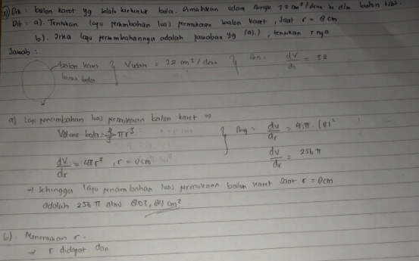
Figure 2. Results of Student Completion in Low Category
Based on the written answers written in Figure 2, it can be seen that students are able to understand the problem and plan solutions or find alternative solutions by making connections from the information known to the problem, but make mistakes in the calculations.
The results of the written test of problem-solving skills in the medium category that have been done show good results. The following will analyze the results of the written test of problem-solving abilities that have been carried out in solving the questions that have been given.
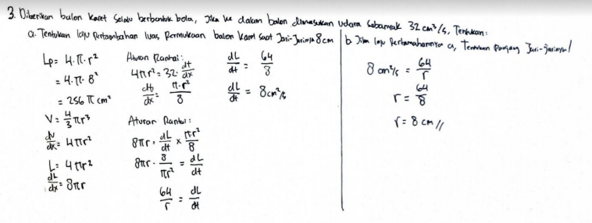
Figure 3. Results of Student Completion in Medium Category
Based on the written answers written in Figure 3, it can be seen that students are able to understand problems and plan solutions or find alternative solutions to carry out plans or calculations by solving these problems. However, in checking the correctness of the question, it appears that students do not understand the results of the calculations that have been obtained.
The results of the written test of problem-solving abilities with high categories that have been done show very good results. The following will analyze the results of the written test of problem-solving abilities that have been carried out in solving the questions.
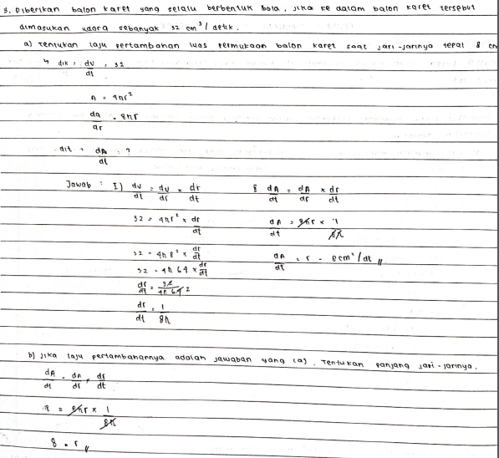
Figure 3. Results of Student Completion in High Category
Based on the written answers written in Figure 4, it can be seen that students are able to understand problems and plan solutions or find alternative solutions to carry out plans or calculations and can also check or test the correctness of calculations or problem solving.

Table 6. Internal Factors Questionnaire Results on Test Results
Indicator |  | Internal factors
Indicator | Category | Intelligence | Attention | Interest | Talent | Motivation | Readiness
1 | Very Low | 73% | 70% | 77% | 43% | 67% | 53%
1 | Low | 80% | 80% | 80% | 60% | 60% | 60%
1 | Medium | 80% | 90% | 80% | 60% | 80% | 70%
1 | High | 66% | 86% | 74% | 54% | 61% | 63%
2 | Very Low | 76% | 76% | 78% | 50% | 68% | 58%
2 | Low | 67% | 90% | 72% | 53% | 60% | 65%
2 | Medium | 64% | 84% | 69% | 50% | 55% | 60%
2 | High | 67% | 88% | 81% | 60% | 67% | 65%
3 | Very Low | 72% | 83% | 74% | 54% | 64% | 62%
3 | Low | 68% | 92% | 76% | 54% | 60% | 64%
3 | Medium | 63% | 85% | 71% | 48% | 53% | 58%
3 | High | 66% | 85% | 77% | 57% | 65% | 65%
4 | Very Low | 72% | 86% | 75% | 54% | 65% | 65%
4 | Low | 62% | 83% | 72% | 52% | 58% | 58%
4 | Medium | 70% | 90% | 80% | 65% | 65% | 70%
4 | High | 60% | 90% | 90% | 40% | 50% | 60%

Based on the results of the questionnaire on internal factors in Table 6 which were reviewed based on indicators on the mathematical problem solving ability of students in indicator (1) having Intelligence, "Good" interests and "Average" talents in all categories. The Attention and Readiness indicators for the low and very low categories are interpreted as "Good" and "Average" while the medium and high categories have more influential interpretations, "Excellent" and "Good". And on the motivation indicator, it turns out that the very low category has an "Average" interpretation while in the other categories it is "Good".
For Indicator (2) in solving mathematical problems, students have "Good" Intelligence and "Average" Talent in all categories. In addition, the Interest indicator in the high category has the interpretation of "Excellent" while in the other categories it is "Good". The Attention and Readiness indicators have an interpretation in the low category having the interpretation of "Good" and "Average" while in the other categories "Excellent" and "Good". And the Motivation indicator has different results, the very low and medium categories have an "Average" interpretation while the low and high categories have a "Good" interpretation.
In Indicator (3) of solving mathematical problems, students have "Excellent" Attention, "Good" Intelligence and Interests and "Average" Talents in all categories. In addition, the Readiness indicator in the medium category has the interpretation of "Average" while in the other categories "Good". And the Motivation indicator has different results, the very low and medium categories have an "Average" interpretation while the low and high categories have a "Good" interpretation.
In Indicator (4) students' mathematical problem solving has "Excellent" attention in all categories. Things happened that were different from the usual pattern, Intelligence for the high category had an "Average" interpretation while the other categories included "Good" as well as the Talent indicator for the high category even had an "Poor" interpretation while the very low and low categories were "Average" and in the medium category "Good". However, it turns out that the interest in the high category has an interpretation of "Excellent" while in the other category it is "Good". And the indicators of Motivation and Readiness have different results, the very low and high categories have the interpretation of "Average" while the low and medium categories have the interpretation of "Good".
Table 7. External Factors Questionnaire Results on Test Results
Indicator |  | External Factors
Indicator | Category | Family Aspects | Community Aspects | School Aspects
1 | Sangat Rendah | 58% | 84% | 80%
1 | Rendah | 67% | 80% | 80%
1 | Sedang | 53% | 87% | 90%
1 | Tinggi | 59% | 84% | 84%
2 | Sangat Rendah | 59% | 84% | 80%
2 | Rendah | 63% | 74% | 88%
2 | Sedang | 56% | 83% | 82%
2 | Tinggi | 60% | 88% | 84%
3 | Sangat Rendah | 62% | 78% | 84%
3 | Rendah | 52% | 85% | 88%
3 | Sedang | 54% | 83% | 80%
3 | Tinggi | 61% | 86% | 85%
4 | Sangat Rendah | 58% | 81% | 86%
4 | Rendah | 57% | 84% | 83%
4 | Sedang | 65% | 87% | 83%
4 | Tinggi | 47% | 87% | 80%
Based on the results of the questionnaire on external factors in table 7 which were reviewed based on indicators on students' mathematical problem solving abilities. Indicator (1) has School Aspects with very low and low categories, namely "Good" and in medium and high categories, namely "Excellent". In the Family Aspect with a very low category the effect is "Good" while in the other category "Average". However, this aspect has the opposite effect from the Community Aspect. In the Community Aspect, the very low category has a "Good" effect, while for the other categories it is "Excellent".
For Indicator (2) in solving mathematical problems, students have Family Aspects with very low and high categories, namely "Good" and in low and medium categories, namely "Average". In the Community Aspect, the very low category has a "Good" effect, while for the other categories it is "Excellent". In addition, the School Aspect for the low category has an interpretation of "Good" and the other category "Excellent".
For Indicator (3) in solving mathematical problems, students have Family Aspects with low and high categories, namely "Good" and in very low and medium categories, namely "Average". In the Community Aspect, the low category has a “Good” effect, while for the other categories “Excellent”. In addition, the School Aspect for the medium category has an interpretation of "Good" and the other category "Excellent".
For Indicator (4) in solving mathematical problems, students have "Excellent" Community Aspects for all categories. In the Family Aspect, the medium category has a “Good” effect, while for the other categories “Average”. In addition, the School Aspect for the high category has an interpretation of "Good" and the other category "Excellent".

CONCLUSION
Based on research on the mathematical problem solving abilities of class XI students in one of the high schools in Bandung City in online learning, it was concluded that the majority of students had a High category on indicators (1) understanding problem and (3) carrying out the plan with their respective percentages 90% and 46%. In indicator (2) devising a plan, the majority of students are in the Medium category with a percentage of 40%. While in indicator (4) looking back, students have difficulty, because in the percentage there are 50% of students in the very low category. Overall, the mathematical problem solving ability of class XI students in one of the high schools in Bandung City in online learning 50% has a medium category, so online learning is fairly smooth, problems only occur in indicator 4, looking back.
Factors - factors that affect the mathematical problem solving ability of class XI students in a high school in the city of Bandung in online learning pay attention to 2 factors, namely internal and external factors. On internal factors, indicators (1) and (3) in the high category of Excellent are influenced by Attention to online learning. In indicator (2) which has a medium category has excellent attention, but so that students improve their abilities, it is necessary to pay attention to the interests and motivation of students so that they become high categories. In indicator (4) the category is very low because Motivation and Readiness in online learning are average, to increase it to a high category, the interest factor of these students must be considered.
On external factors, indicators (1) and (3) in the high category are Excellent, the influence of Community Aspects and School Aspects on online learning. In indicator (2) the medium category is also given by the Excellent Community Aspect and School Aspect, but in order for students to improve their abilities, it is necessary to pay attention to the Family Aspects of the students so that they become high categories. In indicator (4) the category is very low because the Family Aspect in online learning is average. However, from the results of the questionnaire given, external factors do not significantly influence indicator (4). Overall, the data on internal factors and external factors on the mathematical problem solving ability of XI students in one of the high schools in Bandung City in online learning has a strong influence.

BIBLIOGRAPHY
Cahyono, H. (2019). Faktor-Faktor Kesulitan Belajar Siswa Min Janti. Jurnal Dimensi Pendidikan dan Pembelajaran, 7(1), 1-4.
Handarini, O. I., & Wulandari, S. S. (2020). Pembelajaran Daring Sebagai Upaya Study From Home (SFH) Selama Pandemi Covid 19. Jurnal Pendidikan Administrasi Perkantoran (JPAP), 8(3), 496-503.
Hapnita, W. (2018). Faktor Internal Dan Eksternal Yang Dominan Mempengaruhi Hasil Belajar Menggambar Dengan Perangkat Lunak Siswa Kelas Xi Teknik Gambar Bangunan Smk N 1 Padang Tahun 2016/2017. CIVED (Journal of Civil Engineering and Vocational Education), 5(1).
Hudiono. (2005). Peran Pembelajaran Diskursus Multirepresentasi Terhadap Perkembangan Kemampuan Matematik dan Daya Representasi Pada Siswa SLTP. (Disertasi), SPS, UPI. Bandung.
Irham, M dan Wiyani.A.N. 2013. Psikologi Pendidikan. Yogyakarta: Ar-Ruzz Media.
Kemdikbud. (2020). Sikapi COVID-19, Kemendikbud Terbitkan Dua Surat Edaran. [Online]. Diakses dari https://www.kemdikbud.go.id/main/blog/2020/03/sikapi-covid19-kemendikbud-terbitkan-dua-surat-edaran
Mulyadi, 2010. Diagnosis Kesulitan Belajar & Bimbingan Kesulitan Belajar Khusus. Yogyakarta. Nuha Litera.
Nurzaman, A.F. (2015). Penerapan Metode Pembelajaran Thinking Aloud Pair Problem Solving Dengan Pendekatan Saintifik Dalam Peningkatan Kemampuan Problem Solving Siswa SMP. (Skripsi). FPMIPA. UPI. Bandung.
Permata, J. I., & Sandri, Y. (2020). Analisis Kemampuan Pemecahan Masalah Pada Siswa Smp Maniamas Ngabang. Riemann Research of Mathematics and Mathematics Education, 2(1), 10–22.
Riduwan & Akdon. (2009). Rumus dan Dara dalam Analisis Statistika. Bandung: Alfabeta.
Rusyan, T. (1989). Pendidikan Islam dan Keluarga. Jakarta: Gema Insani.
Slameto. (2010). Belajar dan Faktor-faktor yang Mempengaruhi. Jakarta: Rineka Cipta.
Suherman, E. (2011). SAP dan Hands-Out Perkuliahan Ecaluasi Pembelajaran Matematika. Bandung: FPMIPA.
Syaiful. (2012). Peningkatan Kemampuan Pemecahan Masalah Matematis Melalui Pendekatan Pendidikan Matematika Realistik. Edumatica, 2(1),hlm. 37.
Thiangthung, Y. (2016). Applying Polya's four-steps and Schoenfeld's behavior categories to enhance students’ mathematical problem solving. Journal of Advances in Humanities and Social Sciences, 2(5), 261-268.
Zahrotunnimah, Z. (2020). Langkah taktis pemerintah daerah dalam pencegahan penyebaran virus Corona Covid-19 di Indonesia. SALAM: Jurnal Sosial Dan Budaya Syar-I, 7(3), 247-260.

