THE USE OF CONJUNCTION: ELABORATION IN DONALD TRUMP’S SPEECH

Febru Setimaji¹, Teguh Abdulah², Acep Haryudin³

¹IKIP Siliwangi, Terusan Jendral Sudirman street, Cimahi, West Java, Indonesia
² IKIP Siliwangi, Terusan Jendral Sudirman street, Cimahi, West Java, Indonesia
³ IKIP Siliwangi, Terusan Jendral Sudirman street, Cimahi, West Java, Indonesia
¹februhandsome@gmail.com, ²teguh.abdulah.9@gmail.com, ³haryacep@gmail.com

Abstract

Speaking is kind of communication that human needs to give same understanding of mind and works. The term of ‘speech’ has meaning to give some explanation from speaker to audience with many intention from the speaker based on their speech. The speech of Donald Trump at his first state on the january 2018 giving some explanation about the condition in USA today. This research giving the information about the use of conjunction: elaboration in Donald trump speech. The research goal to give some explanation about the types of conjunction and the meaning inside of it. This research used qualitative with the method have been used by the writers is textual analysis method as supported by Frey, et al. The analysis of data show us the precentage of subtype of conjunction: elaboration that Donald trump’s use at his speech are Expository 60%, Exemplifying 8%, Corrective 8%, Particularizing 8%, Resumptive 8%, Verifactive 8%. Donald Trump used appositive so often rather than using clarification on his speech. It means he is less doing clarification to have understanding between him and the audience

Keywords: Speech, Conjunction, Apposition, Clarification

INTRODUCTION

Speaking is kind of communication that human needs to give same understanding of mind and works. According to Tarigan (1986:3) as cited in Haryudin (2017) speaking is communication by speech by arranging the words and sentences that are conveyed orally. The term of ‘speech’ has meaning to give some explanation from speaker to audience with many intention from the speaker based on their speech.

Speech has been being used as an important and strong way to influence others since thousand years ago. The speaker always proposes something in his or her speech, Either implicit or explicit. Speech as spoken words have the strength to influence the audience minds rather than written words in different situations. The words that used in the speech as spoken words can be analyzed through by the functional grammar on the sentences.

Functional grammar are the language feature that provide meaning rather than forms only. The meaning of language are represented in various oral and written teks. With functional grammar, the spoken and written teks will display grammatical connection between individual clauses and utterances is given. These grammatical links can be classified under three general types: reference, ellipsis/subtitution, and conjunction. for the purposes of the research the writers will focus on conjunction as the main subject and consideration when write down the article.

Conjunction making an important role in communication. It acts as a link or a connector between the clauses with other clauses. Conjunction also combines a set of grammatical functions into larger grammatical units. This is reinforced by the opinion of Ramlan (1985: 13) who says conjunctions are words that connect words, parts of sentences, and sentences. The conjunctions will always be used in our daily conversation. Conjunctions can be used in the form of oral and written. It is very hard to list definitively all the items that perform the conjunctive role in english. For this reason the writer use Halliday scheme to classification of conjunctive relations because Halliday has given the writer comprehensive theory about how conjunction can be classified and use in daily conversation with deeper meaning or understanding. Based on Halliday (2014: 612) there are three categories of conjunction: Elaborating, Extending and Enhancing.

There are two categories of elaborating based on conjunction analysis:

Apposition
In this type of elaboration some element is re-presented, or restated, either by expository or by example. For example:
a. Expository: I guess the main editorial rule that we work by is to treat all manuscripts equally. I mean, it doesn’t make any difference who the author is. The word ‘I mean’ have the function to restated the sentence before.
b. Exemplifying: Our humor is founded on very close observation, very, very close observation of reality. You fnd some humorous proverbs, for instance, and the humor is that whoever made these proverbs was not going around the world with his eyes closed. For example, the dog says that those who have buttocks do not know how to sit. The word ‘for instance’ and ‘For example’ have the function to re-presented the word ‘humor’.

Clarification
In this type of elaboration, the elaborated element is not simply restated but reinstated, summarized, made more precise or in some other way clarified for purposes of the discourse. For example: At the 360-K surface, the calculated ozone loss is somewhat less than the observed loss. At least we can say that above about the 400-K level, there does seem to be enough ClO to explain the observed ozone loss. It is the example of corrective clarification with the conjunction ‘at least’ to made the corrective statement from the first and second sentences.

There are two categories of extending based on conjunction analysis:

Addition
Give some explanation of sentences with positive, negative even adversative to extend explanation. Example of conjunction are: Furthermore, Also, Moreover, Nor.

Variation
Variation give some (1) replacive instead, (2) substractive except and (3) alternative or types.

There are four categories of enhancement based on conjunction analysis:

Spatio-Temporal
Place reference may be used conjunctively within a text, with here
and there, spatial adverbs such as behind and nearby, and expressions containing a place
noun or adverb plus reference item, e.g. in the same place, anywhere else. Here spatial
relations are being used as text-creating cohesive devices.

Manner
Manner from the conjunctives create cohesion first done by comparison, and second done by reference to mean, However not often conjungtive but those that are are usually also comparative, example: in the same manner, otherwise.

Causal Conditional
The relation of cause figures very prominently as a cohesive agent. Some cause expressions are general, others relate more specifcally to result, reason or purpose.

Matter
Many expressions of matter are spatial metaphors, involving words like point, ground, feld; and these become conjunctive when coupled with reference items. The relation is either positive or negative condition.

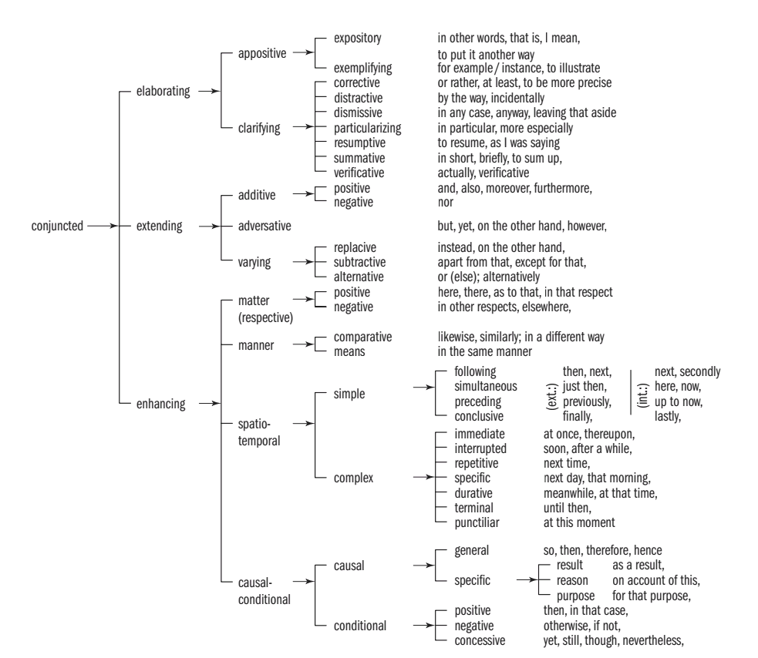
Figures 1. Three categories of conjuncted by Halliday

In this research the writer analyzed the use of conjunction: elaboration in donald trump speech at his first state of the union addres in january 2018. The writer consider choose this topic because of Donald Trump’s speech is one of the phenomenal president’s speech, so the writer interested to analyze the Donald Trump’s speech especially in the use of conjunction: elaboration in his speech.

The Semantic Use of Conjunction

Conjunctions contribute to discourse structure by indicating the semantic meaning or relationship between what has been said and what is to come. As reported by Schleppeğrell (1996: 280), this they do by creating cohesion in texts, either spoken or written, by indicating linkages across varying spans of discourse, and by signalling transitions and displaying the purpose or direction of development of the discourse. Note that there are instances where, though a conjunction ‘stands’ between two words, phrases, clauses or sentences, it is strikingly and unusually far from being used as performing a linking function. Such an instance involves the most frequently used conjunction (or coordinator) and. According to Lang (1991: 597-623), as cited by Hertwig, Benz and Krauss (2008), its commonness and plainness as the most general connective in English language do not mean that it lacks the ability to convey a wider range of relationships between the state of affairs described by the conjuncts.The reasons for linguists enduring fascination with and is that among all coordinating conjunctions, e.g. or, but; it has the least semantic and syntactic limits, the least specific meaning, and the highest context dependency. Consider the following sentence, for example: “Her husband is in the hospital and she is seeing other men.” Kitis (2000: 357-409), as cited in Hertwig, Benz and Krauss (2008) points out, the conjunction and in this sentence does much more than conjoin, connect or link the two clauses. Rather, it functions as an “emotional device” that communicates the speaker’s emotional attitude, surprise, or even outrage.

Importance of Conjunctions

Conjunctions have significance role both in writing or speaking. In effect, Siddiqui (2014) conclude a conjunction is one of the most important parts of a sentence and helps in maintenance of a strong flow of communication in any language. A good knowledge and understanding of various conjunctions enabling us to maintain both ways of communication (that is, verbal and written) conveniently. It is important that the ability to use conjunctions appropriately will aid greatly the speaker while speaking in a confident manner. In addition, conjunctions made creative life into person writing skills abillity by allowing one to combine ideas and compare clauses without having to break up sentences into broken fragments. That is why Leung (2005) notes, “Conjunctions contribute to a better understanding of the use of discourse and they affect the way texts are perceived”. In the words of McClure and Steffensen (1980), conjunctions act as clues drawing attention to and making explicit the logical relationship between propositions. In oral discourse, these relationships may be made clear by context. However, in the written mode, conjunctions are extremely important. This is because readers who fail to note a conjunction or who misunderstand it may interpret the proposition it connects as either totally unrelated, or related in ways unintended by the author perception in other words only one point of view. Thus, they may comprehend each sentence or clause but fail to understand the passage as a whole because of misunderstanding. Conversely, authors who fail giving his/her point of view by using of conjunctions leave their readers guessing about the connections between ideas they have presented. Halliday and Hasan (1976: 226-227) note that one important linguistic resource in communicating information is its conjunctive relation. It is a “specification of the way in which what is to follow is systematically connected to what has gone before”.

METHOD

The method that used by the writer is textual analysis method as supported by frey, et al. (1999). This method used to describe and interpret the characteristics of a recorded or visual message with the purpose to analysis and describing the content, structure, and functions from the messages that contained in research text. Types of this research is library research which collecting and identifying a factual and related information to achieve the goal of the research. The process of collecting data provide by following steps:
- Search the video and the transcript
- Read the transcript
- Choose the conjunction related to the research
- Analyzing the data
- Writing the report of the research

RESULTS AND DISCUSSION

Results
The primary data is the transcription of Trump’s speech at his first state of the Union address on January 30, 2018 at Washington D.C.

Table 1. Conjunction: Elaborating, Appositive list
No. | Sentences | Type of Appositive
1. | All Americans deserve accountability and respect. That is what we are giving to our wonderful heroes, our veterans. | Expository
2. | In Detroit, I halted government mandates that crippled American’s great workers, so we can get motor city reviving its engines again. That is what is happening. | Expository
3. | They want to be in the United States of America. That is where they want to go. Exciting progress is happening every single day. | Expository
4. | In many other countries, these drugs cost far less than what we pay in the United States. And it is very, very unfair. That is why I directed my administration to make fixing the injustice of high drug prices one of my top priorities for the year. | Expository
5. | As America regains its strength, opportunity must be extended to all citizens. That is why this year we will embark on reforming our prisons, to help former inmates who have served their time get a second chance at life. | Expository
6. | The second pillar fully secures the border. That means building a great wall on the Southern border, and it means hiring more heroes like CJ to keep our communities safe. | Exemplifying
7. | American taxpayers generously send those same countries billions of dollars in aid every year. That is why, tonight, I am asking the Congress to pass legislation to help ensure American foreign-assistance dollars always serve American interests, and only go to America’s friends. | Expository
8. | It was that same yearning for freedom that nearly 250 years ago gave birth to a special place called America. It was a small cluster of colonies caught between a great ocean and a vast wilderness. But it was home to an incredible people with a revolutionary idea: that they could rule themselves. That they could chart their own destiny. And that, together, they could light up the world. That is what our country has always been about. That is what Americans have always stood for, always strived for, and always done. | Expository

Table 2. Conjunction: Elaborating, Clarifying list
No. | Sentences | Type of Clarifying
1. | Tonight, I am calling on Congress to produce a bill that generates at least $1.5 trillion for the new infrastructure investment that our country so desperately needs. | Corrective
2. | Struggling communities, especially immigrant communities, will also be helped by immigration policies that focus on the best interests of American workers and American families. | Particularizing
3. | The great news for Americans: 401(k) retirement, pension, and college savings accounts have gone through the roof. And just as I was saying the American people from this podium 11 months ago, we enacted the biggest tax cuts and reforms in American history. | Resumptive
4 | Corey plans to invest his tax cuts into his new home and his two daughters’ education. Corey, please stand. And he is a great welder. This, in fact, is our new American moment. | Verifactive

Discussion

Based on the list above, Trump’s used 6 subtypes of conjunction: Elaboration in his speech at his first state of the Union address on January 30, 2018 at Washington D.C. For the complete summarized we can see on the table below:

Table 3. Percentage the use of conjunction: elaboration in Donald Trump’s speech
No. | Subtypes of conjunction: Elaboration | Total
1. | Expository | 7
2. | Exemplifying | 1
3. | Corrective | 1
4. | Particularizing | 1
5. | Resumptive | 1
6. | Verifactive | 1

The data shows us the percentage of subtype of conjunction: elaboration that Donald trump’s use at his speech are Expository 60%, Exemplifying 8%, Corrective 8%, Particularizing 8%, Resumptive 8%, Verifactive 8%. The result show us that Donald Trump use expository so often. Through the analysis of the speech, Donald Trump usually restated what he want to share to the audience. He give the congress the example and many apposition according to his speech. He use this as the main data from his speech to give the audience the understanding of condition on the USA today.

CONCLUSION

The result from previous point indicate, if Donald Trump using appositive so often rather than using clarification on his speech. It means he is less doing clarification to make same understanding between him and the audience. To provide more meaning in a speech or public speaking the speaker must give more explanation and make a proper conjunction beside of giving only a data without an explanation itself.

ACKNOWLEDGMENTS

Thankfully to Allah S.W.T because giving the writers a good health condition to finish this articles, and our gratitudes towards our parents to financial support, when we made this article. we have been made an efforts in this article, it would be not possible without the kind of support and help of many individuals and institutions. I would like to extend my sincere thanks to all of them. To our lecturer Ida Lisdawati M.Hum and also Acep Haryudin M.Pd , we would say thankyou, because giving us the opportunity to complete the final assignment of Discourse Analysis in the six semester and making this article as a journal for publication at project IKIP Siliwangi.The last I would apologize for the less in the article. Thankyou.

REFERENCES

Frey, L., Botan, C., & Kreps, G. (1999). Investigating communication: An
Introduction to Research Methods (2nd ed.). Boston: Allyn & Bacon.
Halliday, M. A. K. Hasan, Ruqaiya. (1976). Cohesion in English. London. Longman Group Limited.
Halliday, M. A. K., Matthiessen C. (2014). Halliday’s Introduction to Functional Grammar(4th ed.). London: Routledge.
Haryudin, A. (2017). THE STUDENTS’ ENGLISH SPEAKING COMPETENCE BASED ON KTSP CURRICULUM. ELTIN JOURNAL, Journal of English Language Teaching in Indonesia. 4(2): 1-12, https://scholar.google.co.id/citations?user=n9QG5QwAAAAJ&hl=en
Hertwig, Ralph, Benz, Björn and Krauss, Stefan. (2008). Cognition: The Conjunction Fallacy and the many Meanings of and. Amsterdam: ELSEVIER.
Leung, Carrie. (2005). A Comparison of the Use of Major English Conjunctions by American and Hong Kong University Students. Sweden: LUNDS Universitet
McClure, Erica. Steffenson, Margaret. S. (1980). A Study of the Use of Conjunctions across Grades and Ethnic Groups. Illinois: University of Illinois.
Ramlan.(1985). Tata Bahasa Indonesia dan Penggolongan Kata. Yogyakarta: C.V.
Karyono.
Schleppeğrell, Mary J. (1996). Conjunctions in Spoken English and ESL Writing” in Applied Linguistics. Vol. 17, No. 3. London: Oxford University Press.
Siddiqui, Fareed. (2014). Importance of Conjunctions in Business English Communication.
http://fareedsiddiqui.expertscolumn.com/ accessed on 30th May, 2018.
Wolf, R. (2018, January 30). President Donald Trumps addressed Congress Tuesday night for his first state of the Union address. Vox Media. https://www.vox.com/policy-and- politics/2018/1/30/16953472/state-of-the-union-transcript accesed on 30th May, 2018

