WRITING RECOUNT TEXT USING COOPERATIVE SCRIPT: STUDENTS' DIFFICULTIES
Sartika¹, Rissa San Rizqiya²

¹ IKIP Siliwangi
² IKIP Siliwangi
¹ sartikazia@students.ikipsiliwangi.ac.id, ²rissa.sr@ikipsiliwangi.ac.id

Abstract

The objective of the research is to find out the students' difficulties in learning writing recount text using the cooperative script. This research used a qualitative method and the design was descriptive qualitative. The respondents of the research were 15 tenth grade students of Senior High School in Cikadu. The data were obtained from tests and interviews. The results of the research show that the students' difficulties in learning writing recount text using the cooperative script in mechanics, such as punctuation and capital letter. Implies that mechanic aspect tends to be ignored in learning.
Keywords: Cooperative Script, Writing, Students’ Difficulties

INTRODUCTION
Writing is one skill in the English language that important and should be mastered by students. It influences the students' accomplishments in learning English. Writing is one activity of generating and expressing ideas and feeling through words, sentence, and paragraph that is meaningful (Rizkiani, Bhuana & Rizqiya, 2020). Through writing, the students can convey feelings and ideas to others in written form. According to Mundriyah and Parmawati in Harisma, Ilmiah, and Yana (2019), that skill of writing is important, it does not get much attention and enough time in allocation teaching and learning process. Besides, the students also can learn how to arrange the sentences into a good paragraph.
Even though the writing is important, the activity of writing in English context makes the students worry, this is in line with the statement proposed by Hartawan in Harisma et al (2019), writing is a skill that not easy for students to learn in an English context. It means the teacher must apply the right method in teaching writing skills to improve the quality of students' writing, and students do not think that writing in the English context is something that difficult.
Based on the above explanation, this research uses a cooperative script is to know the students' difficulties at the recount text in writing skills.

Definition of Writing
Writing is defined differently by some experts. Gymnastiar & Apsari (2019) say that writing is transforming thoughts and ideas into written form. Moreover, writing is important to increase in learning English because it can build a written communication between other people from a different area, (Hanafiawi, Muharam, and Parmawati 2020). In summary, writing is one process of formulating and organizing ideas with the right words and structure in written form. Writing can be an indirect communication tool between the writer and the reader, which the ideas and messages as communication among people from a different area. Nunan in Apsari (2017) states that in writing skill there are three stages. They are pre-writing, writing, and post-writing. Therefore, in writing skills, many elements must be mastered such as content, vocabulary, organization, language use, and mechanic. These elements are also used in assessing writing.

Definition of Recount Text
According to Anderson cited in Vidya, Nuraini, and Fadloeli (2019), recount text is a piece of text that retells past events, usually in the order in which they occurred. There are three generic structures of recount text. Such as 1) orientation: provide the information about who, where, when that happens; 2) events: tell what happened, present the event steps by steps; 3) re-orientation: it is rounded off the series of events, ( Hyland in Suryaman, 2018).

Definition of Cooperative Script
Cooperative Script model according to Komalasari in (Damayanti, Tarmedi, and Jupri (2018), is one method where students work in pairs and orally outline parts of learned material. Besides, Indriani in Hidayaturrahma, Aisyah, and Yugafiati (2019), says that cooperative script provides a discussion that helps students to understand the task easily, improve the student's understanding of the material and eliminate the students' misconception. In other words, the cooperative script method is a method of learning that requires cooperation between the two-person or more, which one as a speaker and one other as a listener to solve the problem in the task together.
The stages of the cooperative script in the classroom proposed by Muliadi in Gymnastiar & Apsari, (2019). As follows: 1) teachers divide students to the group; 2) the teacher give the materials of each student to read and create a summary; 3) teachers and students choose who first role and speakers and who as a listener; 5) the speaker reads the conclusion of the material that worked on, and the listener identifies incomplete ideas and tries to solve together.; 6) after that, changing positions from which they spoke turned into listeners, and 7) the students and the teacher conclude together.
Concerning the advantages and disadvantages of the cooperative script, Gymnastiar & Apsari, (2019) say that it trains hearing and accuracy also provides feedback for each other faults. He adds that it helps the students to participate actively as each student get a role. Furthermore, Girsang (2018) also mentions that cooperative script encourages students to practice problem-solving by exposing their ideas verbally. It helps students learn to respect smart students and students who are less intelligent and accept the differences that exist. Then, it enables the students to discuss and do social interaction
In other words, based on A'la from Gymnastiar & Apsari, (2019), the disadvantages of the cooperative script is that it is only used for a certain subject. For a large class, it is impossible to involve all the students. This is impacted by the correction given.

METHOD

Kaswan and Suprijadi in Nurfatwa, Alvah, and Fauziah, (2018), state a qualitative defines as the research that places principal importance on studying small samples of intentionally chosen individuals; not trying to control contextual features, but rather seeking, through the variability of methods, to understand things that gain from the informants'; and to producing information a rich and in-depth from the informants' that analyzed. This research design used is descriptive qualitative with the instruments used are tests and interviews. The test uses students' writing tasks about one of their personal experiences. While the interview gained from nine students and consists of five questions that developed from the elements in assessing rubric in writing. The respondent was 15 tenth grade students at a Senior High School in Cikadu.

RESULTS AND DISCUSSION

Results

The results of the data were gained from students' writing tasks. The result is shown below :

Figure 1: Students difficulties in recount text
From the figure above, it can be seen that the students found difficulties in mechanics (32.4%). They also got difficulties in language use (41.5%), vocabulary (48.6%), organization (52.4%), and content (56.4%) . It means that the lowest component was in the mechanic.
In addition, to the results above, interview was conducted to nine of the students. The result of the interview data can be seen below:
In mechanics, they had a problem with punctuation. They did not put full stop or commas. This was because they were afraid if they put the commas incorrectly in their writing. They also still did not know the roles of putting commas in their writing.
Bahasanya kan beda dengan bahasa indonesia, jadi saya takut salam mletakan tanda bacanya. (The language is different from Indonesian, so I am afraid to put the full stop and comma).

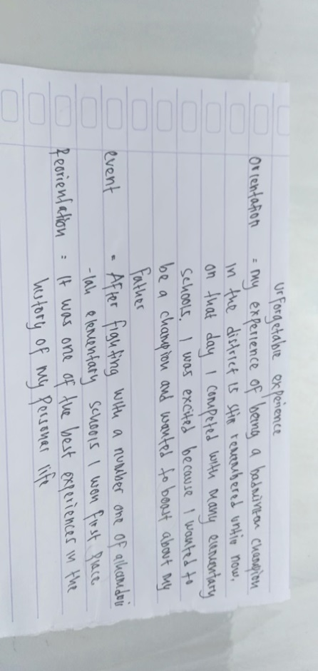

Picture 1: Example of students’ writing in recount text who forgot punctuation
In language use, they had difficulties to identify the pronoun. They thought that there were so many pronouns in English so that it made them confused. Besides, they were also reluctant to open the dictionary.
Karena pronoun dalam bahasa inggris beda-beda dan kalau dicari dikamus kadang-kadang tidak ada. (Because the pronouns in English is different and if look for it in the dictionary sometimes it does not find).
In vocabulary, they got a problem in choosing the correct word. They also thought that the English word was difficult as there was a difference between symbol and sound. They also could not understand about tenses, especially past form.
Saya masih bingung dalam past tensenya , kata-kata bahasa inggris itu susah dan repot harus lihat dulu dikamus. (I am still confused in the past tense, English words are difficult and I have to look at the dictionary first).
In an organization, they were hard to arrange the generic structure of a recount text. They still could not differentiate the orientation, event, and re-orientation.
Saya merasakesulitan karena saya masih suka tertukar apa itu orientation, event, dan re-orientation. (I find it difficult because I still like to change orientation, event, and re-orientation).
In the case of content, the students were a hard to find ideas in writing, especially the main idea.
Sebagian ceritanya sudah lupa jadi sedikit kesulitan, dan ceritanya harus ditulis dalam bahasa inggris jadi susah menyusun kata-katanya. (Some of the stories have been forgotten so it's a little bit difficult, and the stories have to be written in English so it's hard to put together the words).
The result above can be concluded that most of the students' difficulties in mechanics, it was then followed by language use, vocabulary, organization, and content.

Discussion
This research was conducted in one class at tenth grade in Senior High School at Cikadu. In the implementation of this research following the stages of writing. Those are pre-writing, writing, and post-writing. This is in line with the theory by Nunan in Apsari (2017) that states three stages of writing, they are pre-writing, writing, and post-writing.
The students get difficulties in writing. Most students get difficulties with mechanics. It is because the students were unaware they made many errors in mechanics. For example, they do not put a full stop and comma. The reason why vocabulary is not the most problematic for students in tests, because when students do their task they are allowed to see the dictionary and smartphone, so the result of vocabulary quite good.

CONCLUSION

The result of the data shows that the students' difficulties in learning writing recount text using the cooperative script in mechanics. It can be found from the data test and interview. In the mechanic, the students often forgot to put the full stop or commas.

ACKNOWLEDGMENTS

Alhamdulillahirabbil'alamin, firstly all gratitude to Allah S.W.T who gave His blessing and mercy to the researcher, so that can finish this article. Secondly, the researcher would like to say thank for Mrs. Rissa San Rizqiya M.Pd as an article supervisor who always gave advice, and support when conducting this research. Thirdly, the researcher also says thanks to my family, my parents, my husband, and my students for all contributions.
The purpose in written this article is to fulfill one of the requirements of the bachelors' degree in Language English Education and Arts at IKIP Siliwangi, Bandung.

REFERENCES

Apsari, Y. (2017). The Use of Picture Series in Teaching Writing Recount Text. Jurnal Pendidikan Manajemen Perkantoran, 5/II, 51.
Damayanti, A., Tarmedi, E., & Jupri, J. (2018). Implementing Cooperative Script Type of Cooperative Learning Model to Improve Students ’ Activeness in Learning Social Studies. International Journal Pedagogy of Social Studies, 3(1), 129–135.
Girsang, S. E. E. (2018). The Implementation of Cooperative Script Method to Improve Students’ Writing Ability at the Eight Grade Students of SMP Swasta Taman Asuhan. Jurnal Ilmiah Maksitek, 3(1), 79–87.
Gymnastiar, M. A., & Apsari, Y. (2019). Collaborative Approach and Scientific Approach in Teaching Writing Descriptive Text. Jurnal Pendidikan Manajemen Perkantoran, 2(6), 869–878.
Hanafiawi, D., Muharam, H., & Parmawati, A. (2020). The Use of Clustering Technique to Improve Students’ Skill in Writing Descriptive Text. English Community Journal, 2(1), 167. https://doi.org/10.32502/ecj.v2i1.1006
Harisma, I., Ilmiah, G., & Yana, Y. (2019). Improving Students’ Writing Ability Through Project Based-Learning Using Visual Media. PROJECT (Professional Journal of English Education), 2(3), 364. https://doi.org/10.22460/project.v2i3.p364-370
Hidayaturrahma, N. A., Aisyah, N. S., & Yugafiati, R. (2019). Improving Student’s Vocabulary Mastery through Cooperative Script on Descriptive Text. PROJECT (Professional Journal of English Education), 2(2), 181. https://doi.org/10.22460/project.v2i2.p181-186
Nurfatwa, I., Alivah, M. N., & Fauziah, U. N. El. (2018). Semiotics Analysis Logo of STKIP Siliwangi and IKIP Siliwangi. PROJECT (Professional Journal of English Education), 1(5), 532–538.
Rizkiani, S., Bhuana, G. P., & Rizqiya, R. S. (2020). Coded Vs Uncoded Corrective Feedback in Teaching Writing Descriptive Text. ELTIN JOURNAL, Journal of English Language Teaching in Indonesia, 8(1), 55–66.
Suryaman, Y. (2018). Improving Students’ Ability in Writing Recount Text Using Diary at One of Junior High School in Campaka – Cianjur. PROJECT (Professional Journal of English Education), 1(2), 43. https://doi.org/10.22460/project.v1i2.p43-48
Vidya, R., Nuraini, A., & Fadloeli, O. (2019). Improving Students’ Reading Comprehension of Recount Text by Using Think-Pair-Share (TPS) Technique. PROJECT (Professional Journal of English Education), 2(2), 247. https://doi.org/10.22460/project.v2i2.p247-256

