APPENDICES
Appendix 1 : Cover of English textbook “Bahasa Inggris” for Senior High School
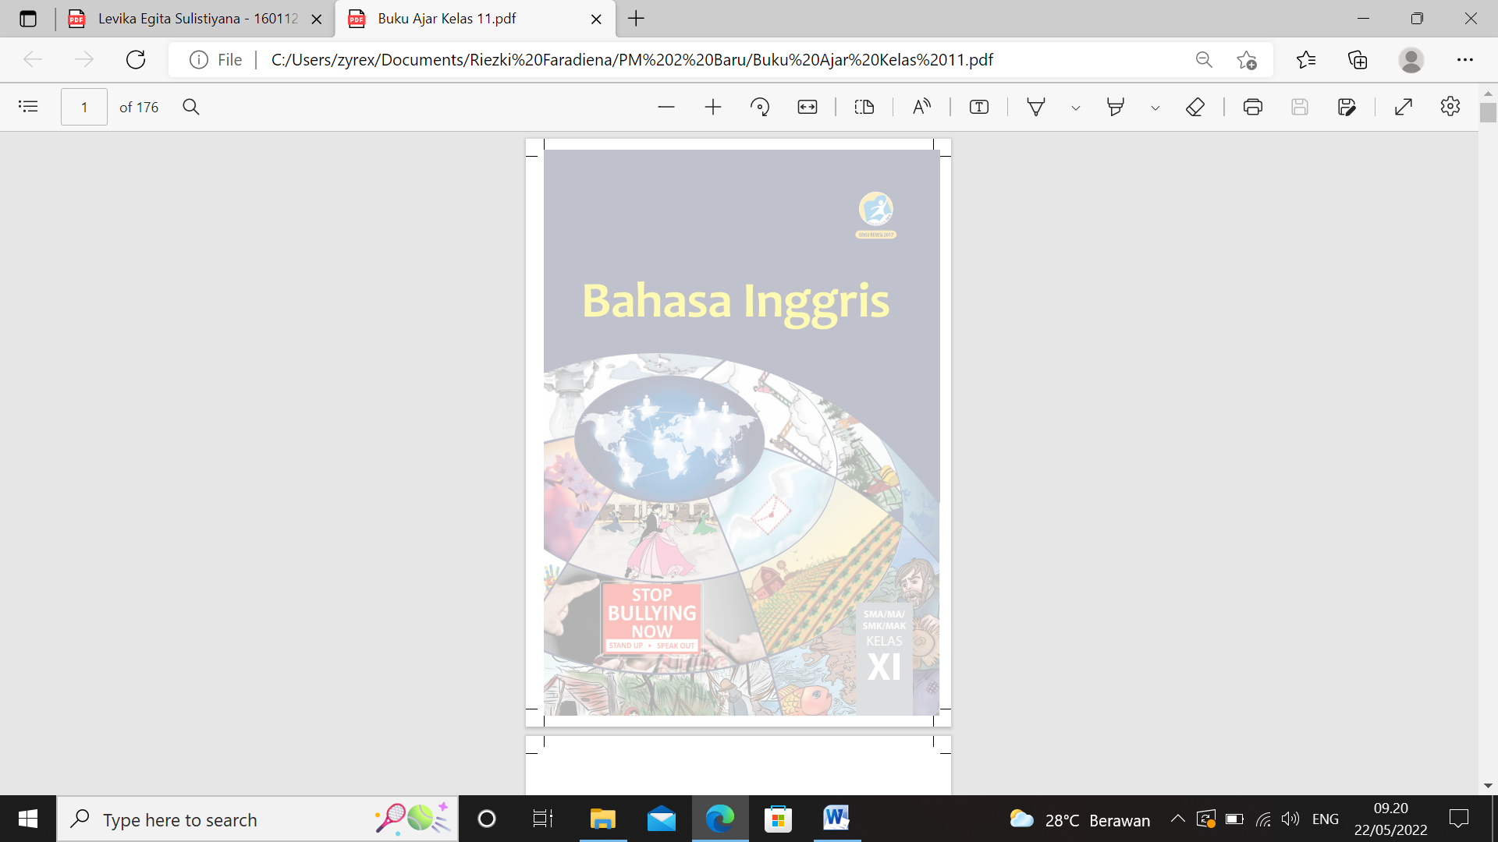

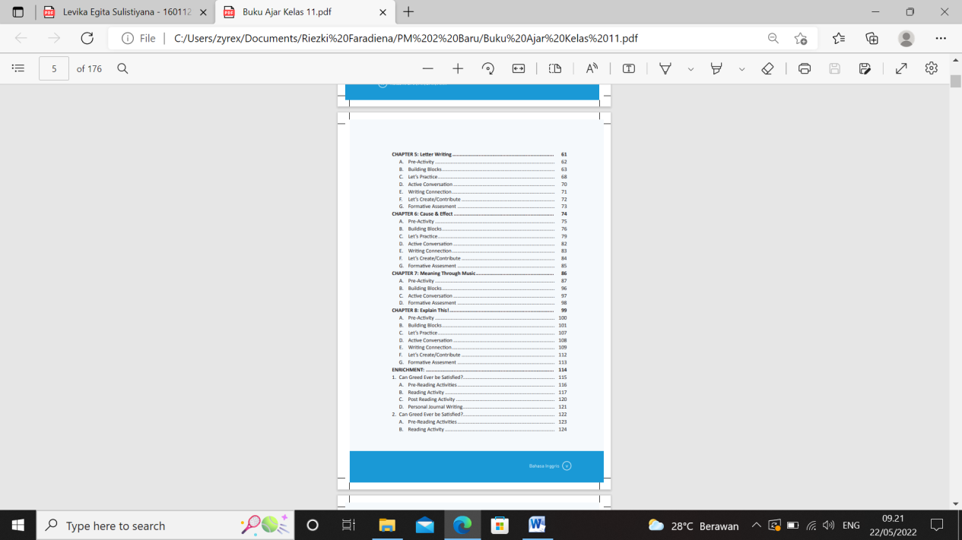
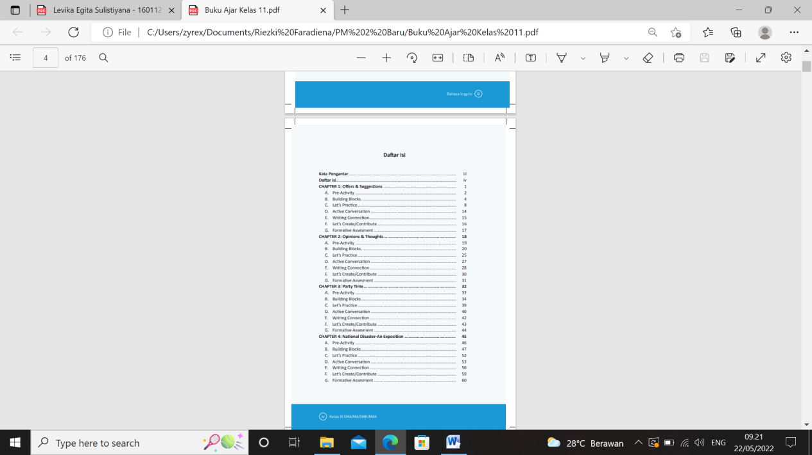
Appendix 2 : Table of content of English Textbook “Bahasa Inggris” for Senior High School

Appendix 3 : Observation Checklist based on Badan Standar Nasional Pendidikan
No. | Aspect of Language | Criteria Fulfillment
1 | The standard of English language use according to the language rules. | √
2 | The use of English which is appropriate with needs of communication learning. | √
3 | The presentation of paragraphs which are presented effectively by considering coherence and cohesiveness. | √
4 | The use of illustrations which are functional and relevant with the materials. | √

No. | Aspect of Language | Criteria Fulfillment
1 | The standard of English language use according to the language rules. | √
2 | The use of English which is appropriate with needs of communication learning. | √
3 | The presentation of paragraphs which are presented effectively by considering coherence and cohesiveness. | √
4 | The use of illustrations which are functional and relevant with the materials. | √

No. | Aspect of Presentation | Criteria Fulfillment
1 | Learning purposes which are stated explicitly and lead to mastery of communication competence.
2 | The presentation of each chapter reflects the logical path and coherence. | √
3 | The presentation of each chapter was arranged from easy to difficult materials. | √
4 | The conformity between tasks and materials. | √
5 | The presentation of each chapter engages students to communicate using English actively.
6 | The presentation of each chapter supports students to be interested in English subject. | √
7 | The presentation of each chapter supports students to reflect and evaluate them. | √

